ASOTIN
COUNTY
PTBA

PUBLIC TRANSIT RIDESHARE PROGRAM
DRIVER REFERENCE GUIDE

April 2023 (Revised)
Welcome to Asotin County PTBA’s RIDESHARE Program
As a full-service transportation agency, Asotin County PTBA provides vehicles for use by commuters like you, who travel to or from work in several Counties. Commuters receive comfortable, convenient travel in exchange for a monthly fare, which covers the cost of the vehicle's operation. The rideshare driver/coordinator rides for free in exchange for the safe operation of the vehicle and other responsibilities such as, collecting monthly fares from the passengers, fueling the vehicle, scheduling maintenance, cleaning the vehicle, and recruiting riders and drivers when necessary. The driver is not employed by Asotin County PTBA.
This manual is designed to provide you with information and forms needed for a smooth rideshare operation. We have detailed the procedures and policies you will need to follow while facilitating as a rideshare driver or coordinator. These procedures and policies may be updated from time to time, as necessary. This manual is designed so you can easily insert updates as they become available.
Please take the time to carefully read this manual and share it with your passengers so everyone knows and understands all aspects of Asotin County PTBA's Public Transit Rideshare Program and your responsibilities and opportunities as a driver, coordinator, bookkeeper, or a passenger.

TABLE OF CONTENTS
INTRODUCTION 1
Asotin County PTBA Contacts 2
RIDESHARE driver qualifications 4
RIDESHARE DRIVER FUNCTION LIST 9
Authorized Drivers 10
emergency authorization 10
Driver Workshop 10
RIDESHARE driver eligibility criteria- minimum standards 11
Definitions 11
Selection Criteria 12
License and Experience 12
Suspension or Revocation of License 12
Violations 12
Physical Condition 12
Employment 12
Back-Up Drivers 13
Back-Up Driver Reimbursement 13
Asotin County PTBA Rights and responsibilities 14
Removal of a RIDESHARE Driver 14
Removal of a RIDESHARE Group/RIDESHARE Vehicle 14
REMOVAL OF AN INDIVIDUAL PASSENGER 15
Insurance 15
Coverage Summary – Liability 15
RIDESHARE driver RIGHTS AND responsibilities 17
Personal Use of the VEHICLE 17
Off-Street Parking 17
Defensive Driving 17
Pre-Trip Inspection 17
Proper Use of Seat Belts 18
Plan Ahead 18
Van Versus Cars 18
Accident Avoidance 19
Inclement Weather 20
The Driver 20
passenger rights and responsibilities 21
Seat Belt Policy 22
Alcohol Policy 22
Prohibited Substances Policy 22
Other Washington State Laws 23
Grievance Procedure 23
Vacation Time 23
Guaranteed Ride Home 24
Eligibility Requirements 24
Bicycle Racks 25
the RIDESHARE group 26
Passenger Recruiting 26
Part-Time Passengers 26
Operational Rules 27
Route Changes 27
Emergency Back-Up Systems 27
Back-Up Vehicle 28
Back-Up Carpools 28
Weather Emergencies 30
RIDESHARE Fares – accounting 31
Fixed Monthly Costs 31
Variable Monthly Costs 32
Computing Daily Rates 32
Formulas 32
Fare Reimbursement Procedure 33
Receipt of NSF Checks 33
LIMITATIONs 33
REPORTING REQUIREMENTS 35
Monthly Reporting 35
Miles Traveled 38
Report Submittal 38
SUBSIDY OR FULL FARE REIMBURSEMENT 38
ACCIDENT PROCEDURES 39
At the Accident Scene 39
During and After the Accident 40
Asotin County PTBA (Incident or Accident) 41
MOre safety advice 44
maintenance 49
Routine Maintenance and Repairs 49
Preventive Maintenance 49
Tires 50
Safety-Related Defects 50
Windshield Repairs 50
winter maintenance 50
Diesel Fuel Anti-Gel – Diesel Vehicles Only 50
Engine Block Heaters 51
Air Conditioning 51
Winter Tires 51
Washing Your V 51
transmissions 52
Automatic Transmission 52
Emergencies 52
Brakes Fail 52
Accelerator Sticks 52
Air Conditioning Compressor Failure 53
breakdowns 53
Preventable Road Calls 54
Emergency Purchases 54
FUELING 54
RIDESHARE agreement 56-59

FIGURES
Figure 1. Asotin County PTBA Facility Map. 3
Figure 2. Warning Device Placement – Two-Lane or Undivided Highway. 45
Figure 3. Warning Device Placement – Obstructed View. 45
Figure 4. Warning Device Placement – One Way or Divided Highway. 46

FORMS
1. Rideshare Driver Application…………………...…………………………………..5
2. Asotin County PTBA Release Authorization……………………………………..8
3. Back-Up Carpool Roster…………………………………………………………....29
4. Sample Rideshare Monthly Reports.………………………………………........ 36
5. Event Report……………………………………..……………………………..…41/42
6. Witness Courtesy Card…………………………………………………………..….43
7. Vehicle Body Damage Report………….……………………………….……...47/48

INTRODUCTION
Passengers pay a monthly fare for the ride to work; Asotin County PTBA purchases the equipment and administers the program. Drivers have a choice not to pay; instead, they drive the vehicle as their contribution to the rideshare's success.
Drivers and passengers make up the pool of resources. The driver's major benefits include, but are not limited to:
- The "free ride"
- Possible lower insurance rates on personal vehicle
- Less miles on personal vehicle
- Maybe not having to own that extra commuter car
- Personal satisfaction for doing the right thing
The passenger's major benefits include, but are not limited to:
- A very affordable ride
- A safe, relaxed, reliable commute
- Less wear and tear on personal car
- Potentially lower insurance rates on personal vehicle
- Maybe unnecessary to own extra commuter car
- Personal satisfaction for easing traffic congestion and air pollution
As a driver or passenger, it is expected that you will adhere to the Rideshare Agreement and follow policy as it relates to this manual. WELCOME ABOARD!

Asotin County PTBA Contacts
Asotin County PTBA
1494 Poplar Street
Clarkston, WA 99403
Admin. | 509-758-3567 |  | Rideshare |  |  | 509-758-3567 | Fax | 509-758-3594
Routine Business Needs
General Information |  |  |  | Monthly Reports |  |  |  |  |  |  |  |  | Passenger Assistance
Policy Questions |  |  |  | Scheduling Driver Workshops |  |  |  |  |  |  |  |  | Fares
Maintenance |  |  |  | Driver Applications |  |  |  |  |  |  |  |  | Reporting Accidents
 |  |  |  |  | Work |  |  |  |  |  |  | e-mail
 |  | Jenny George |  |  | 509-758-3567 |  |  |  |  |  |  | jgeorge@asotincoptba.com
 |  | Greg Gill |  |  | 509-758-3567 |  |  |  |  |  |  | gill@asotincoptba.com
Additional Emergency Assistance
 |  |  |  |  |  | Work |  |  |  |  | Shop Hours
Rideshare Office Answering Service |  |  |  |  |  | 509-758-3567 |  |  |  |  | 24 Hours a Day – 7 days a week
Les Schwab Tire Service |  |  |  |  |  | 509-751-9661 |  |  |  |  | M-Sat 7:30 – 6:00
Bernards Towing Service |  |  |  |  |  | 208-743-9504 |  |  |  |  | 24 Hours a Day – 7 days a week

Figure 1. Asotin County PTBA Facility Map.

Asotin County PTBA
1494 Poplar Street
Clarkston, WA 99403

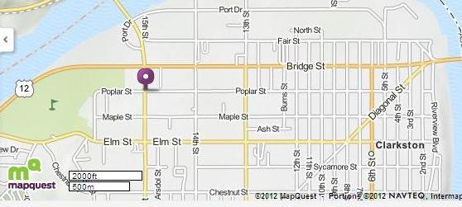

©2011 MapQuest, Inc. Use of directions and maps is subject to the MapQuest Terms of Use. We make no guarantee of the accuracy.

RIDESHARE driver qualifications
A safe driver is the single most important ingredient in any rideshare program. In order for the Asotin County PTBA Rideshare Program to ensure safe, reliable transportation to the public, the transit agency has established specific criteria to qualify those persons who have volunteered to drive a public rideshare vehicle.
- The use of an Asotin County PTBA vanpool vehicle is a privilege.
- Asotin County PTBA vans must be driven by authorized van drivers only.
- Asotin County PTBA reserves the right to revoke the use of a van.
- Report any moving violations, accidents, or health changes that may affect your driving record.
Asotin County PTBA will look at your MVR, Motor Vehicle Record (driving history) for the past three years. This ensures that any driver we allow behind the wheel of a vehicle has a safe, consistent driving background. Asotin County PTBA checks Washington drivers MVR monthly with “Envision”, a driver monitoring software. Each year, Asotin County PTBA will request our Idaho Drivers provide us with a MVR; there will be a cost for this. If there is any new information, it could affect eligibility. Please report any moving violations, accidents, or health changes that you incur while acting as a driver in the Asotin County PTBA Rideshare Program.
Prospective drivers are required to fill out and sign:
- A Release Authorization
- A Rideshare Agreement
- Driver Function List
- Driver Application
These forms can be found in your vehicle's log book. Please mail or deliver the forms promptly to expedite processing. All information will be kept confidential.
Because the responsibilities of a rideshare driver include defensive driving, fare collection, and delivering a group of people to and from work on time, a number of important items must be reviewed.
- Asotin County PTBA will obtain a copy of your unrestricted license.
- Asotin County PTBA will obtain a record (abstract) of the applicant's three-year personal and employment driving history.
- Asotin County PTBA may contact the applicant's employer, insurance company, and/or physician to obtain information necessary for approval. This will be accomplished only with the applicant’s consent.
Form 1. RIDESHARE Driver Application. (3 pages)
Asotin County PTBA
PUBLIC TRANSIT RIDESHARE DRIVER application
This application will be used to establish your eligibility as an operator of a public transit rideshare. The information you provide helps us assure you, your Rideshare group, and the public that standards of safety and accountability are maintained. We appreciate your cooperation and interest in our Rideshare program.
Driver applicants must answer all questions. Return completed application with copy of valid Drivers License to your Rideshare program representative.
 | Application for (circle): |  |  |  |  |  |  |  |  |  | Driver |  |  | Backup-up Driver |  |  |  |  |  |  |  |  | Bookkeeper
1. | Name: |  |  |  |  |  |  |  |  |  |  |  |  |  |  |  |  |  | Home Phone:
 | Address: |  |  |  |  |  |  |  |  |  |  |  |  |  |  |  |  |  | Work Phone:
 | Years/Months at this address:
 | If less than 2 years, previous address:
2. | Do you have a current and valid State Driver’s License?
 | Yes |  |  |  |  |  | No
 | If not, please explain:
 | How long have you had a driver’s license? Years/Months:
 | Driver’s License Number:
 | Expiration date: |  |  |  |  |  |  |  |  |  |  |  |  |  |  | Date of birth:
 | Are there any restrictions on your driver’s license? |  |  |  |  |  |  |  |  |  |  |  |  |  |  |  |  | Yes |  |  |  |  |  |  | No
 | If restricted, state type (including vision) and date of restriction:
 | Have you ever had your driver’s license suspended, revoked, or refused? |  |  |  |  |  |  |  |  |  |  |  |  |  |  |  |  |  |  |  |  |  |  |  | Yes |  |  | No
 | If so, please explain:
Have you ever been convicted of driving while intoxicated or under the influence of drugs?
Yes ____ No ____
If yes, please explain (date, charge, jurisdiction, etc.):

 | Indicate all driving violations or citations (other than parking) that you have been convicted of, forfeited bail, or paid any fines for during the past three years. Please give full details, including dates, below:
A:
  Date:__________ | Time:_________ | Location (city/state):__________________________
  Conviction:_____________________ | Recorded speed cited for:____________________
 | If speeding, posted limit:________________________
Remarks:_________________________________________________________________
________________________________________________________________________
B:
  Date:__________ | Time:_________ | Location (city/state):__________________________
  Conviction:_____________________ | Recorded speed cited for:____________________
 | If speeding, posted limit:_________________________
Remarks:_________________________________________________________________
________________________________________________________________________
 | Please indicate below any vehicle accidents of any type or cause you have been involved in:
  Date:__________ | Time:_________ | Driver:____________ | Violation:_________________
  Who’s at fault:____________ | Damage to your vehicle?_________ | Amount: $_________
  Bodily Injury?_____________ | Damage to your property?________ | Amount: $_________
Description:______________________________________________________________
________________________________________________________________________

  Date:__________ | Time:_________ | Driver:____________ | Violation:________________
  Who’s at fault:____________ | Damage to your vehicle?_________ | Amount: $_________
  Bodily Injury?_____________ | Damage to your property?________ | Amount: $_________
Description:_______________________________________________________________
________________________________________________________________________

 | Can you provide off-street parking for the vehicle? Yes____ No ____ Other ____

3. | Name of your automobile insurance company:
 | Has an insurance company ever refused, cancelled, not renewed, or given notice of intention to refuse automobile insurance to you? Yes _______ No _______
 | If yes, list company and agent’s name and phone:
 | Indicate which (circle): |  |  |  |  |  |  |  |  |  | Cancelled |  |  |  | Refused |  |  |  |  |  |  | Non-renewal
 | Date: |  |  |  |  |  |  |  | Reason:
4. | Current job title: |  |  |  |  |  |  |  |  |  |  |  |  | Employer:
 | Work address:
 | Supervisor’s name and phone number:
 | In the last year, how many times have you been late to work?
 | In the last year, how many times have you had to work overtime?
 | How long have you worked for this employer? |  |  |  |  |  |  |  |  |  |  |  |  | Years |  |  |  |  |  |  | Months
 | Work Hours: Workdays (circle): M T W Th F S S
5. | Have you ever been required by the State to file evidence of Fiscal Responsibility (SR22)?
 | Yes |  |  |  | No
 | If yes, please explain:
By signing below, I understand that this application warrants a verification of information provided. Applications for Volunteer Driver authorize Asotin County Transit to obtain as often as desired my driving record, including all Department of Licensing actions that have taken place regarding the driver’s license I now hold, have held, or in the future may obtain.
I hereby grant permission for PTBA to request information to obtain a credit, insurance, medical, or job history report or other documentation they require. I understand that this information will be kept confidential.
This release continues in effect as long as I continue to serve as a volunteer driver on an Asotin County Public Transit Rideshare vehicle.
Signature: |  |  |  |  |  |  |  |  |  |  |  |  |  |  |  | Date:
I have read and agree with the stated terms for Driver Selection and Driver Functions.
Signature: |  |  |  |  |  |  |  |  |  |  |  |  |  |  |  | Date:
Form 2. Asotin County PTBA Release Authorization.
Asotin County PTBA
RELEASE AUTHORIZATION

I authorize Asotin County PTBA to conduct a complete driving record search in conjunction with the review of my application for the position of a volunteer rideshare driver, this ensures that any driver we allow behind the wheel of a vehicle has a safe, consistent driving background. Asotin County PTBA checks Washington drivers motor vehicle records monthly with “Envision”, a driver monitoring software.
Do you have any conditions that may affect your ability to perform all requirements of operating the rideshare vehicle?
Yes No
If yes, please explain:

My Date of Birth is
My Driver’s License No. is
Signature
Name (print clearly)
Vehicle No.
Date
e-mail Address Work:
Home:

RIDESHARE DRIVER FUNCTION LIST
As an Asotin County PTBA volunteer rideshare driver, you must be able to:
- Understand and uphold Washington State traffic laws.
- Understand, uphold, and apply Asotin County PTBA Rideshare policies and procedures.
- Understand and apply the principals of defensive driving.
- Safely operate a 15- to 21-foot van, carrying 3 to 15 passengers on a planned route, in potentially heavy traffic, over a variety of roadways and narrow city streets, while attending to an established time schedule.
- Wear a seat belt at all times.
- Enter and exit the vehicle’s driver seat, sitting upright in the seat at all times.
- Bend, kneel, reach, stretch, and turn, as appropriate, to inspect all items in the vehicle that you are going to operate.
- Bend, reach, stretch, and turn, as appropriate, to manipulate all controls, while safely operating the vehicle.
- Read vehicle instrument panel/gauges and traffic signs, and watch for pedestrians and other obstructions while driving during the day and night.
- Assess rapidly changing traffic situations, evaluate hazardous conditions, and take prompt evasive action to deal with them safely.
- Provide for the well-being of yourself and passengers in emergencies and special situations.
- Communicate orally and in writing with the public, rideshare participants, Asotin County PTBA representatives, and public safety officers.
- Be sure that written and verbal reports are completed accurately and on time.
- Ensure that daily, weekly, and monthly vehicle maintenance inspections are performed, and the vehicle receives servicing at established intervals.
- Ensure that vehicle interior and exterior are cleaned at regular intervals.
- Make sure that vehicle is fueled at self-service pumps, and check tire pressure and wear every fueling.
- Be reachable by cell, telephone, or e-mail during normal business hours. Be responsive when we need to communicate with you.
- Be able to recognize when a physical or mental condition or required medication may impair the ability to safely operate a Rideshare vehicle and take appropriate action to find a substitute or make other arrangements.
Signature: Date: Vehicle #

Authorized Drivers
Asotin County PTBA vehicles must be driven by authorized vehicle drivers only. Authorized drivers are those that have attended the mandatory driver workshop and meet the selection criteria established by the staff at Asotin County PTBA. Any commuter group found operating a vehicle by an unauthorized driver will lose their vehicle. Asotin County PTBA's rideshare insurance coverage will not be extended to any incident occurring while the vehicle is driven by an unauthorized driver. The liability for any incident would be assumed by the unauthorized driver. Please do not risk the financial liability to yourself.
- Only authorized drivers are permitted to operate Asotin County PTBA vehicles.
- Authorized drivers must first complete a mandatory Driver Workshop and meet the selection criteria established by Asotin County PTBA.

emergency authorization
In an emergency, a rider may request temporary authorization to drive, from the Transit Agency Rideshare staff. After Rideshare staff review, if authorized, a rider may drive for a one-day trip. No one may drive without authorization. This emergency authorization must be followed up with attendance at one of the next two scheduled mandatory driver orientations. A short interview at the time of the request would include information on the following:

- Full name of the individual
- State driver's license number
- Date of birth
- Years of driving experience
- Past accidents or traffic violations

Driver Workshop
Asotin County PTBA requires that all drivers complete a rideshare Driver Workshop. This orientation course is typically 1 hour. It is offered to you by the rideshare service staff. Agenda items covered include defensive driving with hands on practice, maintenance, fueling options, bookkeeping practices, passenger sensitivity, fare structures, and accident procedures. It is mandatory that all drivers attend the workshop.
The workshop will be scheduled at a time of your convenience; weeknights, Saturday mornings, or on a day off. All in all, the course is designed to benefit you, so that you are comfortable doing business with Asotin County PTBA, safely and efficiently.

RIDESHARE driver eligibility criteria- minimum standards
Within a three-year period, prospective, eligible drivers shall have:
- No more than one minor, non-cited accident and one minor moving violation
- No more than two minor, non-cited accidents with no minor moving violations
- No major moving violation
- No major at-fault accidents
- No seat belt violations
For existing rideshare drivers, eligibility will be terminated if within a three-year period they have:
- More than one minor, non-cited accident and one minor moving violation
- Two minor moving violations
- Any major moving violation
- Any major at-fault accident, cited or non-cited
- More than two minor accidents
- Multiple complaints (Asotin County PTBA Rideshare staff reserves the right to terminate a driver or take disciplinary action, such as suspension, based on frequency, severity, and validity)
- No seatbelts violations

Definitions
- "Minor accident" shall be defined as involving less than $3,500 in total damage and no bodily injury.
- “Major accident” shall be defined as verifiable event involving more than $3,500 in total damage and/or bodily injury.
- "Cited" means an accident in which the driver was given a traffic citation for a violation of a law or regulation in connection with an accident.
- "Verifiable" means that the Rideshare Coordinator is provided with copies of documents that establish damages, facts, and legal outcomes.
- “Major Moving Violations” include convictions for speeding greater than 10 mph over the speed limit, failure to yield, failure to stop, speeding in a school zone, following too close, driving too fast for conditions, disobeying road signs, improper lane travel, illegal overtaking/passing, cell phone/texting violations, and seatbelt violations. Traffic camera violations received while driving a rideshare vehicle are considered major moving violations. Major violations are also any convictions for driving under the influence of drugs or alcohol, open container, refusal to take a drug/alcohol test, careless or reckless driving, reckless endangerment, felony or negligent driving, leaving the scene of an accident, and or hit and run convictions.

- “Minor Moving Violations” include anything less than a major moving violation defined above, speeding 10 mph over the limit or less, and violation of the carpool lanes.

Selection Criteria
Selection of primary drivers, as well as back-up drivers, is dependent upon the criteria discussed in the following sections.

License and Experience
A potential driver must possess a current, unrestricted driver's license (prescription lens requirement is acceptable). Review of other restrictions on an individual basis for applicability to safety. Driver must have five years of driving experience in the U.S. or Canada.

Suspension or Revocation of License
Report of a suspension/revocation within the past three years will cause a potential driver's application to be rejected. Report of a license suspension/revocation within the last seven years for reckless driving or hit and run or leaving the scene of an accident or driving while under the influence of alcohol/drugs or driving while impaired, and or a felony violation will result in application rejection.

Violations
A "Failure to Appear" (FTA) on a driving record in the last three years will result in application rejection. No felony convictions are allowed. FTA, failure to yield, failure to stop, or speeding in excess of 11 mph, are all considered major violations. The driver would automatically lose eligibility for at least a three-year period with the combination of circumstances or violations described in the list on page 10.

Physical Condition
The potential driver must be in good health. Any condition that may impair the driver's ability to operate the vehicle will result in application rejection. Poor eyesight (correctable by lenses) is acceptable. A potential driver may be required to have a physical examination, at the driver's expense, to determine good health. Please self-report any health status change, including use of prescription or non-prescription drugs which would affect driving performance.

Employment
As an indicator of a driver's reliability and availability, a potential driver must show stable employment. Work attendance record and amount of business travel or training may be considered.

Back-Up Drivers
Many of the rideshares now divide driving responsibilities between two or more people. From the standpoint of driver fatigue, burn-out, and attitude adjustment, this system is what we prefer. If you have been the sole driver of your rideshare for several months and are doing virtually all the driving, please discuss the idea of obtaining some help for yourself within your rideshare. We strongly recommend that primary drivers, who do the majority of the work, rotate out as primary driver for at least one month out of the year. We recommend that at least two other back-up drivers be trained and ready to assist for a variety of reasons: business appointments, classes, vacation, sick time, or temporary work location re-assignments.

Back-Up Driver Reimbursement
When required to drive, the back-up driver should be credited a daily fare for each day of driving. The Rideshare Program allows credits of two days per month and in addition, to be fair, a driver may include one (five day) work week of vacation credit per year. The days can be saved up to use together, but must be applied within a specific 12-month period. (See discussion of Vacation credit, page 22.) This makes a total of 29 business days per year the primary driver can have someone cover their duties and get paid to do so. The primary driver is responsible for paying the cost of any days exceeding the 29-day limit. The formula for calculating back-up driver credits is: Divide your individual monthly fare by the number of average work days in the month (work shifts determine variable days. Shift 8 x 9’s = 19 days average, 5 x 8’s = 21 days average, 4 x 10’s = 17 days average and a rotating 12-hour shift = 15 days.) This will give you a daily rate to deduct. Deduct only one-half of the daily rates if you only drive one trip, one direction. Reimbursement would be written off on a back-up driver’s next monthly fare check.

Asotin County PTBA Rights and responsibilities
Asotin County PTBA is the legal owner of the rideshare vehicle and, therefore, has specific rights and responsibilities to the Rideshare Program, which are discussed below. Please remember, the use of an Asotin County PTBA rideshare vehicle is a privilege, one that should be treated with respect.
Asotin County PTBA reserves the right to revoke the use of a vehicle, as detailed in the following sections.

Removal of a RIDESHARE Driver
- Operating the vehicle in a manner inconsistent with the agreement
- Unsafe driving (reckless, negligent, or illegal)
- Involvement in an "at-fault" accident
- Citation(s) for traffic violation(s)
- Complaints; based on frequency or severity. Complaints from a Police Official.
(Asotin County PTBA reserves the right to hire a private/confidential 3rd party to investigate)
- Using the vehicle for hire, hauling garbage, pulling boats, trailers, debris, towing, or other unapproved purposes
- Using the vehicle to push or jump-start another vehicle
- Driving the vehicle outside Asotin County PTBA’s 50-mile radius boundaries
- Using the vehicle off road, on beaches, infields or any other unsafe environment
- Removal of seats for any reason
- Personal use of the vehicle
- Operation of the vehicle under the influence of drugs or alcohol
- Unreported accident or incident in a rideshare vehicle
- Consistently late or unreliable service
- Failure to abide by Asotin County PTBA's no smoking policy
- Failure to accurately submit revenues (fares) in accordance with reporting requirements and comply with accounting deadlines

Removal of a RIDESHARE Group/RIDESHARE Vehicle
- Condone or encourage a driver to speed, hide the fact from Asotin County PTBA staff
- Unauthorized drivers operating the vehicle
- Unreported damage or abuse of the vehicle
- Consistently low passengers or revenues, below required levels
- Consumption of alcoholic beverages, or smoking cigarettes

REMOVAL OF AN INDIVIDUAL PASSENGER
- Failure to pay monthly fees
- Not using seat belts
- Failure to abide by majority consensus, as established in the Rideshare Agreement
- Rude, abusive, or intimidating behavior, as determined by the majority
- Failure to abide by Asotin County PTBA's no smoking policy

Insurance
Asotin County PTBA provides appropriate insurance coverage for rideshares through the Washington State Transit Insurance Pool (WSTIP). The premiums for this coverage are paid by the monthly passenger fares. The insurance rates charged for rideshares are a reflection of market trends and the accident history of the transit program. Please remember, only drivers and back-up drivers authorized by Asotin County PTBA may drive rideshare vehicles.
- Intentional malicious or illegal acts are excluded from insurance coverage, including driving under the influence of alcohol or other drugs.
- Any incident involving the vehicle or a person must be reported immediately.

Coverage Summary – Liability

The agency will pay all sums resulting from the use of a covered vehicle of the agency when the authorized user of the vehicle is held legally liable for bodily injury or property damages caused in the accident. The limit per occurrence is $12 million.

Passengers: Passengers are covered for bodily injuries that they may receive while occupying a covered vehicle involved in an accident, which the agency's insurance would customarily respond under the terms and conditions of its ensuing agreement.
Drivers: The agency will provide coverage to all rideshare drivers who, while operating the vehicle within the terms and conditions of the Rideshare Agreement, suffer a bodily injury to a limit of $35,000 per occurrence. This is known as Personal Injury Protection (PIP).
- This medical expense protection limit shall be secondary to any medical plan the rideshare driver may already have available at the time of the accident that resulted in bodily injury.
- If no other medical benefit source is available, this PIP shall be primary and will provide benefits up to the limits provided ($35,000.00).

Operators and Passengers: Uninsured and Underinsured motorist coverage (UIM): The agency will provide UIM coverage to a limit of $60,000 per occurrence.

Minor Incidents: Any incident involving the vehicle or a person around the vehicle, (where Asotin County PTBA may have a liability issue) must be reported immediately to Asotin County PTBA Rideshare. Always be sure to record and report the person's name, phone number, and address. This requirement includes such occurrences as a passenger injured upon entering or exiting the vehicle, acts of vandalism, hitting an animal, or any other minor incidents taking place within a 20-foot radius of the vehicle that pertain to the vehicle or riders.

RIDESHARE driver RIGHTS AND responsibilities

Personal Use of the VEHICLE
No personal use of the vehicle is permitted at any time. We are bound by this constraint because of our company policy and liability limits. Please do not have your family on board for any reason, unless they are paid participants in the Asotin County PTBA Rideshare Program. Also, do not run errands in our vehicles. The public perception of our program focuses on “their tax dollars spent wisely” and grocery shopping with the vehicle or dropping your child at a sports practice, for examples, would look wrong.

Off-Street Parking
The vehicle is to be parked off street at the residence of the rideshare group member during non-commute hours and as often as possible at other times. The vehicle can also be parked in a secured agency approved location.

Defensive Driving
The defensive driving formula:
Awareness | + | Alertness | + | Caution | + | Consideration | = | A SAFE DRIVER ATTITUDE
(Knowledge of traffic laws and limits) |  | (To traffic situations and how vehicle is performing) |  | (Practice patience) |  | (Act as you would like others to act toward you)

Pre-Trip Inspection
- Walk around the vehicle – see any obstacles or vandalism?

- Check underneath for fluid drips and obvious mechanical defects.

- Check condition of tires’ tread and proper air inflation psi.
FORD = 55 front / 80 rear CHEVY/GMC = 50 front / 80 rear

- Unplug the block heater cord if in use.

- Clean windshield and all windows, tail and headlights if needed.

- When starting up, watch the vehicle gauges. Have fuel? Alternator OK?
- Test if turn signals, lights and horn are working.
- Adjust and clean mirrors if necessary.
- Weekly – check fuel, oil, washer fluid, belt, transmission fluid and brake fluid

Proper Use of Seat Belts
- Seatbelts must be worn at all times.
- Shoulder straps must be properly worn.
- Do not pull away until all passengers are seated and buckled in.
- Remove passengers for non-compliance of seat belt law.

Plan Ahead
- Allow yourself time.

- Know the hazards on your route.

Van Versus Cars
- Safe operation is a different challenge; abrupt maneuvers may create risk of roll-overs.

- More blind spots.

- More height and clearance /weight /width considerations.

- Center of gravity is higher and shifted to the rear; increasing the propensity to roll.

- Meets more wind force resistance.

- Acceleration may feel slower in diesel vans.

- Stopping distance when fully loaded is longer; vans equipped with ABS.
- Turning radius is wider, may require a different sight line at corners.

Accident Avoidance
- Make sure the vehicle windows are not blocked by decals or decorations. No hanging objects from the rearview mirror.
- Watch out for the other guy!
- Recognize the difference between taking "unnecessary chances" and taking a "calculated risk."
- Secure the vehicle when boarding or off-loading passengers – set your emergency brake and the transmission in park. Remember this safety feature: you cannot shift out of park again until your foot is on the brake pedal.
- It is a good idea to drive with your headlights on. At end of trip, turn them off.
- Drive with your hands at 3 and 9 on the steering wheel due to the air bag.
- No cellular phone use while you are driving.
- A moment's inattention or simple distraction can be a serious mistake.
- Remember to keep scanning your mirrors.
- Follow the 4 second “cushion of safety” rule.
- Leave yourself an out.
- Respect intersections and right-of-way. Stop lights are never for sure – clear it and cover your brakes, watch out for stale green or yellow lights.
- Restrict the space between your vehicle and curb to less than the width of an auto when making a right turn.
- Watch for dangers and accident traps such as, animals, downed vehicles, brake lights or construction.
- Watch pedestrian crossings, loading zones, school bus stops, and railroad crossings.
- When turning right, look both left and right.
- When backing up ask for help and honk.
- When passing, ask yourself, “is this necessary to make a safer situation?”
- When being passed, accept it and ease off to help the other driver around you.
- Use your turn signals and hazard flashers to let others know your intentions.
- Be aware of speed limits and obey them.
- When merging, it helps to ask and use a spotter.
- Look to the left and behind you before moving from a stop or loading zone.
- Go to the light for left turns and crossing heavy traffic lanes.
- Look a block ahead, anticipate and drive according to several vehicle reactions not just the bumper immediately in front of you.
- Visibility may be impaired with bicycles loaded on the bike rack. Compensate for the increased length on the front of the vehicle if a bike rack is installed on your vehicle.
- Set the parking brake and take your keys at the trip's end, then lock the doors.

Inclement Weather
- Know that conditions change from town to outer areas.

- With snow and ice driving, you will go slower, so allow more time.

- Increase your following distance to have reaction time to stop.

- Turn into the skid – wheel the direction you want the front of vehicle to go.

- Understand that visibility is reduced; please clear all your windows of frost.

- Black ice is common on bridges, in shady spots, at intersections and down hills.

- Do not use cruise control if you suspect icy conditions.

- Winterize the vehicle: do you need an ice scraper, washer fluid, better tires, and extension cord to plug in the diesel vans, radiator cover or anti-gel?

The Driver
- Self-report any health changes, use of prescription drugs, or medical issues.

- Self-report any accidents or ticket violations.

- Let someone else drive if you are tired, do not feel well or have had a bad day.

- Get help with conflict resolution so you can concentrate on the task of safe driving.
- There are special procedures for lift operation and safe wheelchair securement. The rideshare staff will train you as needed.

passenger rights and responsibilities
In keeping with the cooperative nature of a rideshare, the passengers agree to assume certain personal responsibilities relative to their own commute trips. Each passenger must read and sign a Rideshare Agreement. Failure to do so will result in a denial of service. The agreement forms can be found in your Rideshare Log Book. When new passengers are added, drivers must send validated agreements to Asotin County PTBA.
The passenger agrees to:
- Pay to the driver his/her monthly passenger fee, as established by Asotin County PTBA, by the first of each month.
- Abide by all day-to-day rules of the vehicle, as established by the majority vote of the rideshare members.
- Abide by all rules established by Asotin County PTBA, as defined in the agreement.
- Notify the driver in advance of all anticipated non-use of the vehicle due to such factors as vacations, business travel, overtime, etc., so that unnecessary stops are avoided.
- Notify the driver or the nearest fellow passenger of non-use of the vehicle due to illness.
- Notify the driver 15 calendar days in advance of planned termination of program participation.
- Help maintain passenger occupancy at chosen capacity.
- Help keep the vehicle clean and tidy.
- Find alternate transportation on the days when the vehicle may not be available.
- Find alternate transportation when work or personal schedules do not allow participation in the rideshare.
- Abide by arbitration in disputes arising out of the day-to-day operational rules.
- Not abuse the Guaranteed Ride Home Program.
- Wear a seat belt at all times.
- Abide by the no alcohol/smoking policies established by Asotin County PTBA.

Seat Belt Policy
Under Washington State Law RCW 46.61.688(3), it is mandatory that "all passengers in all vehicles wear a seat belt safety device, in a properly adjusted and securely fastened manner."
Asotin County PTBA Rideshare will not provide service to any individual that refuses
to wear a seat belt.
The driver is legally responsible (and citable) for all passengers under age 16 to wear seat belts in any vehicle.
All adult passengers are personally responsible (and citable) to wear seat belts in any vehicle.
Asotin County PTBA is responsible for supplying seat belt safety devices to all passengers.

Alcohol Policy
It is expressly forbidden by Washington State Law (RCW 46.61.519) and Asotin County PTBA policy, in compliance with Washington State law, to consume alcohol on a publicly owned vehicle.

Prohibited Substances Policy
Asotin County PTBA does not allow the driving of a rideshare vehicle under the influence of any illegal drugs. An illegal drug is any drug or substance identified in Schedule I through V of Section 202 of the Controlled Substance Act (21 U.S.C. 812) and is further defined by 21 CFR 1300.11 through 1300.15. This includes, but is not limited to: marijuana, amphetamines, opiates, phencyclidine (PCP), and cocaine, as well as any drug not approved for medical use by the U.S. Drug Enforcement Administration or the U.S. Food and Drug Administration. Illegal use includes the use of any illegal drug, the misuse of legally prescribed drugs, or the use of illegally obtained prescription drugs at any time. Marijuana is considered a banned substance per the federal government.

This policy does not prohibit the appropriate use of legally prescribed drugs and non-prescription medications. However, it is the responsibility of the volunteer rideshare driver to inform his/her physician when being prescribed medication(s) that they are driving a rideshare vehicle and ask about driver impairment and possible side effects. The volunteer driver should only use medically authorized drugs or over the counter medications in a manner which will not impair their driving or elect not to drive when using prescribed drugs or over the counter impairing drugs. It is also the responsibility of the volunteer driver to remove themselves from service if they are not able to drive because of any adverse effects due to medications.

You may not drive the rideshare vehicle after consuming beverages or substances containing alcohol, including any medication, food, candy, or any other substance that contains alcohol.

Other Washington State Laws
It is further against Washington State law (RCW 9.91.025 Unlawful Bus Conduct) (Public Conveyance) and Asotin County PTBA policy to hinder, disturb, deface, litter, carry a lighted pipe, cigar, or cigarette, to engage in loud, raucous, unruly, harmful, or harassing behavior, or to carry and consume alcohol in a Asotin County PTBA vehicle or on Asotin County PTBA property.
RCW references concerning behavior are:
- RCW 9.91.025
- RCW 35.58.272
- RCW 460.04.355
- RCW 46.61.519

Grievance Procedure
On occasions, there may be conflicts that cannot be resolved within your rideshare groups. These conflicts will be resolved by the Rideshare Program Coordinator.
If a person directly involved with the conflict or action in question wishes to protest the decision of the Rideshare Program Coordinator, such protest must be submitted in writing to the Board of Directors.
The Board of Directors will review information from those parties concerned with the action, as well as the decision of the Rideshare Program Coordinator. The Board of Directors will then uphold, modify, or reverse the decision of the Rideshare Program Coordinator.

Vacation Time
After participating in the Rideshare Program for six consecutive months, passengers are qualified to take or "save" one free week of vacation credit. Because of fluctuating work schedules, Asotin County PTBA could not concentrate on individual differences, but decided instead to make a constant, steady formula: When an eligible passenger wishes to take his/her free week, a simple rule to follow is: divide the individual’s fare by 4 and subtract that cost from their check for that month. A passenger may use two weeks within a year, so think of it as; “with every 6th payment, a passenger should take the credit.” The passenger does not need to physically be gone from the vehicle to enjoy this earned savings. Rideshare staff does not call and remind individuals of their earned vacation credit, passengers should keep track of this record for themselves. Asotin County PTBA will only allow accrual to build up to two weeks. You may not save it for years. Drivers also can take advantage of this privilege at a rate of one week per year. Their allowance would be defined in days (not driving), rather than a monetary amount, since they work on the premise of “free” fare already.

Guaranteed Ride Home
We want you to share rides to work, but that may mean you are helpless in an emergency. Now you can relax! Use Asotin County PTBA's Guaranteed Ride Home Program to get you to the destination of your choice for any of the following reasons.
- Your child or other immediate family member is sick or injured
- A family crisis
- An unexpected business appointment
- Unscheduled overtime that is not covered by your employer's guaranteed ride home program
- When normal (homebound) rideshare trip arrangements fail
Asotin County PTBA's Guaranteed Ride Home Program does not cover personal errands, pre-planned appointments; working late without a supervisor's authorization. Your employer should cover your guaranteed ride home if it is scheduled overtime.
The Guaranteed Ride Home Program is available to you any hour of the day or night, excluding weekends.

Eligibility Requirements
Any passenger or driver who is currently participating in the Rideshare Program (and monthly fares are paid current) is eligible.
There is a very limited budget for the Guaranteed Ride Home Program. Abuse of the program will be evaluated on a case-by-case basis.

Bicycle Racks
Bicycle racks capable of holding two bikes, are available to each rideshare group. Owners are responsible for providing their own locking devices.

the RIDESHARE group
Asotin County PTBA will start a new rideshare group with three to ten passengers. Asotin County PTBA must recover the operational cost of the vehicle or consider closing the route if the recruiting prospects appear dim and payments fall below the monthly operational cost.

Passenger Recruiting
Passenger waiting lists should be maintained by the rideshare drivers. If you need passengers, we will try to help you locate and recruit them, but the most effective methods are to recruit at the job site or ask current passengers to help recruit. If possible, advertise in the company newsletter. It is in the passenger's best interest to assist in recruiting to keep their rates low and keep the vehicle from being closed because it continues to run at a loss.
You may request yellow "Passengers Wanted" signs from the rideshare office. These signs can be posted in the vehicle windows or at other conspicuous places (bulletin boards, etc.).
When new passengers join your rideshare, obtain a Rideshare Agreement and mail or email it to the rideshare office as soon as possible.
Remember, as a public program, we are concerned about the potential for discrimination. We realize that the major factor in your selection of new passengers is trip compatibility. However, please be careful not to make a decision that could be construed as showing favoritism or prejudice when you select new passengers.

Part-Time Passengers
Definition of a part-time passenger is a commuter who only works a part-time (or shortened) work week. Example: Monday-Wednesday-Friday shifts. A part-time passenger would not need daily travel arrangements.
Whether or not you choose to carry part-time passengers is a group decision. If your vehicle is not full, part-time passengers are a good idea because they reduce the fare all passengers must pay. However, you should only take a part-time passenger with the understanding that if a full-time passenger comes along, the part-time passenger may lose his/her seat if the part-time passenger decides not to pay the full fare after given the first choice.
You should charge part-time passengers a prorated fare derived from the Asotin County PTBA Rideshare Fare table. Part-time passengers are subject to the same rules as other rideshare passengers. Completion of the Asotin County PTBA Rideshare Agreement is required, and part-time passengers must pay their fares in advance.

Operational Rules
A rideshare is a cooperative endeavor. Daily operational rules should be decided by everyone in the rideshare group. Whenever possible, it is advised to make and agree upon operating rules by majority vote. Try to keep the rules flexible, to best meet the needs of the rideshare. Subjects may include:
- Radio – Sample rule: The radio may be played softly on the station agreed upon by the group.
- Wait time at pick-up points – Sample rule: The rideshare will wait a maximum of 3 minutes at any pick-up point.
- Smoking – Asotin County PTBA's policy does not allow smoking in any vehicle.
- Seating arrangements – Sample rule: Back-up driver, who takes the vehicle to the farthest work site, sits in the navigator seat. Other seats are "open choice" in the manner that will best facilitate loading and unloading.
- Passenger capacity – Sample rule: The vehicle will run with 10 passengers instead of 12. The monthly fare and level of comfort will both be higher as a result.
- Vehicle temperature – Sample rule: The interior temperature will be kept at a level of comfort appreciated by the majority, unless it interferes directly with the driver's alertness or comfort.

Route Changes
Every time you lose or gain a passenger in your commuter group, the route "twitches" in terms of schedule and service potential. To make sure we can send potential passengers to you in a qualified manner, notify us of your route changes.

Emergency Back-Up Systems
- Asotin County PTBA’s insurance does not extend to personal vehicles.
- If you choose to drive yourself and others when your primary rideshare ride has failed, you do so at your own financial risk.
There may be occasions when your primary vehicle is not available for the commute trip. This might be caused by breakdown, vandalism, or an incident, such as the reading lights left on overnight. These occasions, although rare, can and should be anticipated and a back-up plan identified.

Back-Up Vehicles
Asotin County PTBA has several "spare" vehicles that support the overall system in case of breakdown or during maintenance. If your vehicle fails in the morning, chances are that there is a vehicle at the main office that you can use that day. Because of the early morning hour and your schedule, you will likely have to pick up the vehicle. However, your rideshare service representative can help you. Discuss it with them. If the breakdown occurs during the commute or during the work day, Asotin County PTBA Rideshare staff can most likely have a vehicle delivered to your job site. Call your rideshare service representative.

Back-Up Carpools
In the event your vehicle fails you in the morning before your commute trip, carpools can be easily arranged for emergency use. Usually, at least three carpools will be necessary to handle an emergency when the vehicle will not start in the morning.
Example: The battery was stolen from the vehicle over night, so it will not start. You are out of time and are supposed to be on the road NOW! Your passengers will soon be waiting at their stops.
Have a plan in place, of who will drive from certain points in the route. Have a list of home and work telephone numbers of all the passengers so contact can be made quickly and smoothly. It works best to share responsibility among the volunteer back-up drivers of calling the passengers. This information should be decided upon before an emergency occurs.
Everyone missing service on an Asotin County PTBA vehicle in this example will be given a credit for the missed trip. If you provided transportation for others and yourself, take a credit off the next month's fare. The passengers should take their credited amount and help pay the carpool driver for gas (but this is only a courtesy suggestion, not enforceable.) We promote this plan because it is a workable alternative.
Asotin County PTBA's insurance does not extend to personal vehicles.
Credits will be evaluated if misused, because most problems have a solution. For example: 1) We cannot support fare deductions due to repeated mechanical failure where driver or passenger error (such as head lights or reading lights left on) is evident. 2) We also cannot allow credits repeatedly for lack of back-up driver help. Each vehicle should have enough drivers to assure success and avoid credits.

Form 3. Back-Up Carpool Roster.
Back-Up Carpool Roster

Drivers should pre-arrange a telephone system between passengers to ensure communication of changes in commute arrangements.

Driver/Passenger Name | Home Phone | Work Phone

Note: Asotin County PTBA and the drivers have no responsibility for finding alternative transportation for the individual passengers who cannot utilize the rideshare because of temporarily conflicting work or personal schedules

Weather Emergencies
In Asotin County PTBA's service area, ice and snow storms may make driving conditions extremely hazardous. Asotin County PTBA Rideshare groups are allowed five snow days per winter season. A snow day may be used at a driver's discretion due to hazardous conditions. Call your Rideshare Fleet Coordinator to help you determine whether to use a snow day or commute in the rideshare vehicle.
- Asotin County PTBA’s insurance does not extend to personal vehicles. Drive your personal vehicle at your own risk.
- Call your Rideshare Coordinator to help you determine whether to use a snow day or commute in a rideshare vehicle.
If a very serious weather emergency arises, Asotin County PTBA reserves the right to request that the vehicle not be operated until the emergency passes.
Rideshare vehicles should not be operated if Asotin County PTBA bus service has suspended operations due to a weather emergency.

RIDESHARE Fares – accounting
The Rideshare Program operates as a business, but with a non-profit philosophy. This means that it is the goal of the program to "break even." The costs charged to the passenger do not include staff telephones, desks, and postage or marketing types of expenses. Asotin County PTBA Rideshare fares do cover the operating and administrative costs (i.e., fixed costs for insurance, depreciation and office management and variable costs for fuel, oil, repairs, tires, etc.) of each rideshare vehicle. Fares are calculated to break even with paying passengers and a free driver in a 15-passenger van for a reasonable rate. It is very important that each vehicle generate the revenue necessary to pay the cost of the route. EXAMPLE:
If your van is supposed to generate $909.47 per month to meet the costs, and you have twelve passengers splitting the cost, the monthly rate is $75.79. ($909.47 divided by 12)
If you lose one passenger (down to eleven in this example) or the group elects to have fewer passengers for more comfort, the cost of doing business remains the same. The individual rates would increase due to fewer people generating the $909.47. You must adjust the rate to $82.68. ($909.47 divided by 11)
When you recruit additional passengers, you may decrease the monthly rate again. This is the primary reason it is in the passenger's best interest to assist in recruiting efforts.
If a rideshare is losing money and there is not a significant change or a reasonable effort to cover the losses, the rideshare service staff must consider closing the route and reassigning the vehicle to a more productive group of commuters. Asotin County PTBA is not in the business of closing routes, but will do so if in the best interest of the program and Asotin County PTBA.
Rideshare fares only reflect fixed costs and variable costs.

Fixed Monthly Costs
Fixed costs are comprised of two elements, amortization (loan payments) and insurance. These costs are established periodically and should not change throughout the year, but may change year-to-year.
Capital recovery (cost of the loan) is based on re-paying 80 percent of the acquisition cost of the vehicle over an 84-month period (seven years). Twenty percent of the acquisition cost is expected to be recovered at the point of surplus.
Insurance is charged at a rate of .07 cents per mile and .06 cents per boarding at this time. Asotin County PTBA earns adjustments or credits for frequency and severity of accidents. Insurance rates can and usually do change up or down on an annual basis.
Total fixed monthly costs as of October 1, 2008 and until further notice are $342.47 per month, per van.

Variable Monthly Costs
Variable costs are determined by the number of miles the vehicle runs. Variable costs are comprised of the following elements:
Fuel and oil | 16.80 cents per mile
Maintenance (repairs and service) | 20.64 cents per mile
Tires | 2.40 cents per mile
Contingency (license checks, rentals, small parts,  office supplies, glass, vandalism, guaranteed ride home, etc.) | 8.16 cents per mile
Total | 48 cents per mile

Computing Daily Rates
Variable costs are calculated on commute miles traveled per month, based on the assumption that the rideshare is used for commuting an average number of business days per month. (See formulas below for average work days per shift.)
Each passenger's monthly fare equals the total of the fixed and variable costs together, divided by the total number of paying passengers in the vehicle.
To pay for extra days the vehicle may get used, (above the established base amount) money should be collected at 25.3 cents per mile, which is only the variable rate.

Formulas
- For a 5 x 8's work week, monthly average miles computed by multiplying daily route miles by 21 average commuting days per month.
- For an 8 x 9's work week, monthly average miles computed by multiplying daily route miles by 19 average commuting days per month.
- For a 4 x 10's work week, monthly average miles are computed by: multiplying daily route miles by 17 average commuting days per month.
- For a 12 hour rotating shift, monthly average miles are computed by: multiplying daily route miles traveled by 15 average commuting days per month.

Fare Reimbursement Procedure
The reimbursement policy concerning any individual who terminates membership from any rideshare route is as follows:
- With a 15-day termination notice, any unused portion of that monthly fare will be reimbursed entirely.
- With a 7-day termination notice, any unused portion of that monthly fare will be reimbursed at 50 percent of the unused portion.
- On any rideshare vacancy to occur with less than a 7-day notice, there will be no reimbursement whatsoever, unless a job transfer or medical emergency occurs.
- When a passenger terminates from the program with no notice, we are deprived of the opportunity to fill that vacancy and, in essence, that vacancy is subsidized by every other rideshare commuter in that vehicle because costs remain the same.
The driver's input will be part of the decision-making process regarding reimbursement requests. If there is no "free will" exercised (such as lay-offs or some medical emergencies), Asotin County PTBA will reimburse any unused portion.

Receipt of NSF Checks
The following is proposed for the handling of NSF checks received by Asotin County PTBA for passengers in the rideshare vehicles.
- When a check is received back from the bank for a rideshare passenger, the passenger will be contacted and asked to provide a money order or bank check for payment.
- If the rideshare coordinator has not been able to resolve the NSF check within 15 days of receipt notification, the rideshare coordinator will assume the responsibility for collecting the funds and may involve a collection agency.

LIMITATIONs
The following provisions govern the authorization to operate Rideshare and conditions of use:
- The vehicle shall at all times be operated in a manner complimentary to the public nature of this program. The vehicle shall be kept clean, driven in a safe manner at all times, and not operated while under the influence of alcohol and/or drugs. All members shall act in a courteous manner, and the unique character of this vehicle’s use shall be explained if such is quested.
- Operation of the vehicle is restricted to Asotin County PTBA-approved drivers.
- The vehicle is to be parked off street at the residence of a Rideshare group member during non-commute hours and as often as possible at other times, or other secured agency approved locations.
- Personal use of the vehicle is limited as prescribed by Asotin County PTBA. Such use, if permitted, shall not interfere with the availability of the vehicle for regularly established commuting.
- The vehicle is not to be used for hire, to pull trailers, boats, etc.; to haul garbage, debris, or excessive loads; or for any purpose requiring the removal of seats.
- The vehicle is to be driven only on hard-surfaced streets and highways and other normal access roads and driveways. It is not to be driven off-road, on beaches, in fields, or in any other potentially unsafe environment.
- As with all vehicles, and particularly the 15-passenger van, the vehicle must be driven in such a manner as to avoid exposure to rollover. Fifteen-passenger van operation should incorporate the recommendations provided by the National Highway Traffic Safety Administration for reducing the risk of rollover crashes in the 15-passenger vans.
- Width and height clearance requirements are to be observed at all times.

REPORTING REQUIREMENTS
As an agent of Asotin County PTBA, each rideshare’s bookkeeper (usually the primary driver/coordinator) is responsible for collecting the monthly fares from all members of the group at the beginning of the month. We recommend that the fares be paid in the form of check or money order and be turned into the driver by the 1st of each month. All fares must be submitted to Asotin County PTBA by the 10th of the month.
- Fares must be paid by passengers in the form of check or money order by the 1st of each month to the bookkeeper.
- All fares must be submitted to Asotin County PTBA by the 10th of each month.

Monthly Reporting
The Rideshare Monthly Report includes the following components:
- Part I is a daily mileage log, from the previous month, that includes daily odometer readings, total miles traveled, commute and non-commute miles, and a record of fuel and oil purchased. We need to know how much fuel you are buying, whether or not your particular outlet provides you with a receipt. List the gallons in the Fuel/Oil column in Part I.
- Part II is a monthly record of tire tread depth (outside, center, and inside). This section also includes a space to record the vehicle route (i.e., start and pick-up locations and shift hours). This will help us stay current on your routes.
- Part III is a passenger record that includes passenger names, start and termination dates, credits and vacations accumulated for the back-up driver, and the amount paid by each passenger. Please fill in all columns accurately.
- Part IV is a monthly vehicle inspection report. Minor defects and body damage should be listed in this section.
A Monthly Report sample is illustrated on pages 36 and 37.
Form 4. Sample Rideshare Monthly Report. (2 Pages)
RIDESHARE MONTHLY REPORT
 |  |  | May 1, 2001 |  |  | May 31, 2001 |  |  | 3 |  | WSU
 |  |  | FROM |  |  | TO |  |  | VEHICLE NUMBER |  | RIDESHARE ROUTE
 |  |  | 40,000 |  |  |  |  |  | Steven Spielberg
 |  |  | BEGINNING ODOMETER READING |  |  |  |  |  | DRIVER/COORDINATOR
 |  | PART I |  | Date | End of Day  Odometer Reading |  | Total Miles |  |  | Commute Miles |  | Non-Commute Miles | Fuel/Oil
 |  |  |  | 5/1/01 | 40,000 |  | 80 |  |  | 80
 |  |  |  | 5/2/01 | 40,160 |  | 80 |  |  | --
 |  |  |  | 5/3/01 | 40,247 |  | 87 |  |  | 80 |  | 7-fueling | 28.4
 |  |  |  | 5/4/01 | 40,328 |  | 81 |  |  | 81
 |  |  |  | 5/7/01 | 40,408 |  | 80 |  |  | 80
 |  |  |  | 5/8/01 | 40,489 |  | 81 |  |  | 81
 |  |  |  | 5/9/01 | 40,570 |  | 81 |  |  | 81
 |  |  |  | 5/10/01 | 40,651 |  | 81 |  |  | 81
 |  |  |  | 5/11/01 | 40,737 |  | 86 |  |  | 80 |  | 6-fueling | 31.2

PARt II
PARt II | Tire Tread Depth |  |  |  | Outside |  | Center |  | Inside
PARt II |  |  | LF |  | 5/32 |  | 6/32 |  | 6/32
PARt II |  |  | LR |  | 8/32 |  | 8/32 |  | 8/32
PARt II |  |  | RF |  | 7/32 |  | 7/32 |  | 7/32
PARt II |  |  | RR |  | 8/32 |  | 8/32 |  | 8/32
PARt II | Date Measured | 5/30/01 | SP |  | 10/32 |  | 10/32 |  | 10/32

Rideshare Route Stop Points

Form 4. Sample Rideshare Monthly Report. (2 Pages)
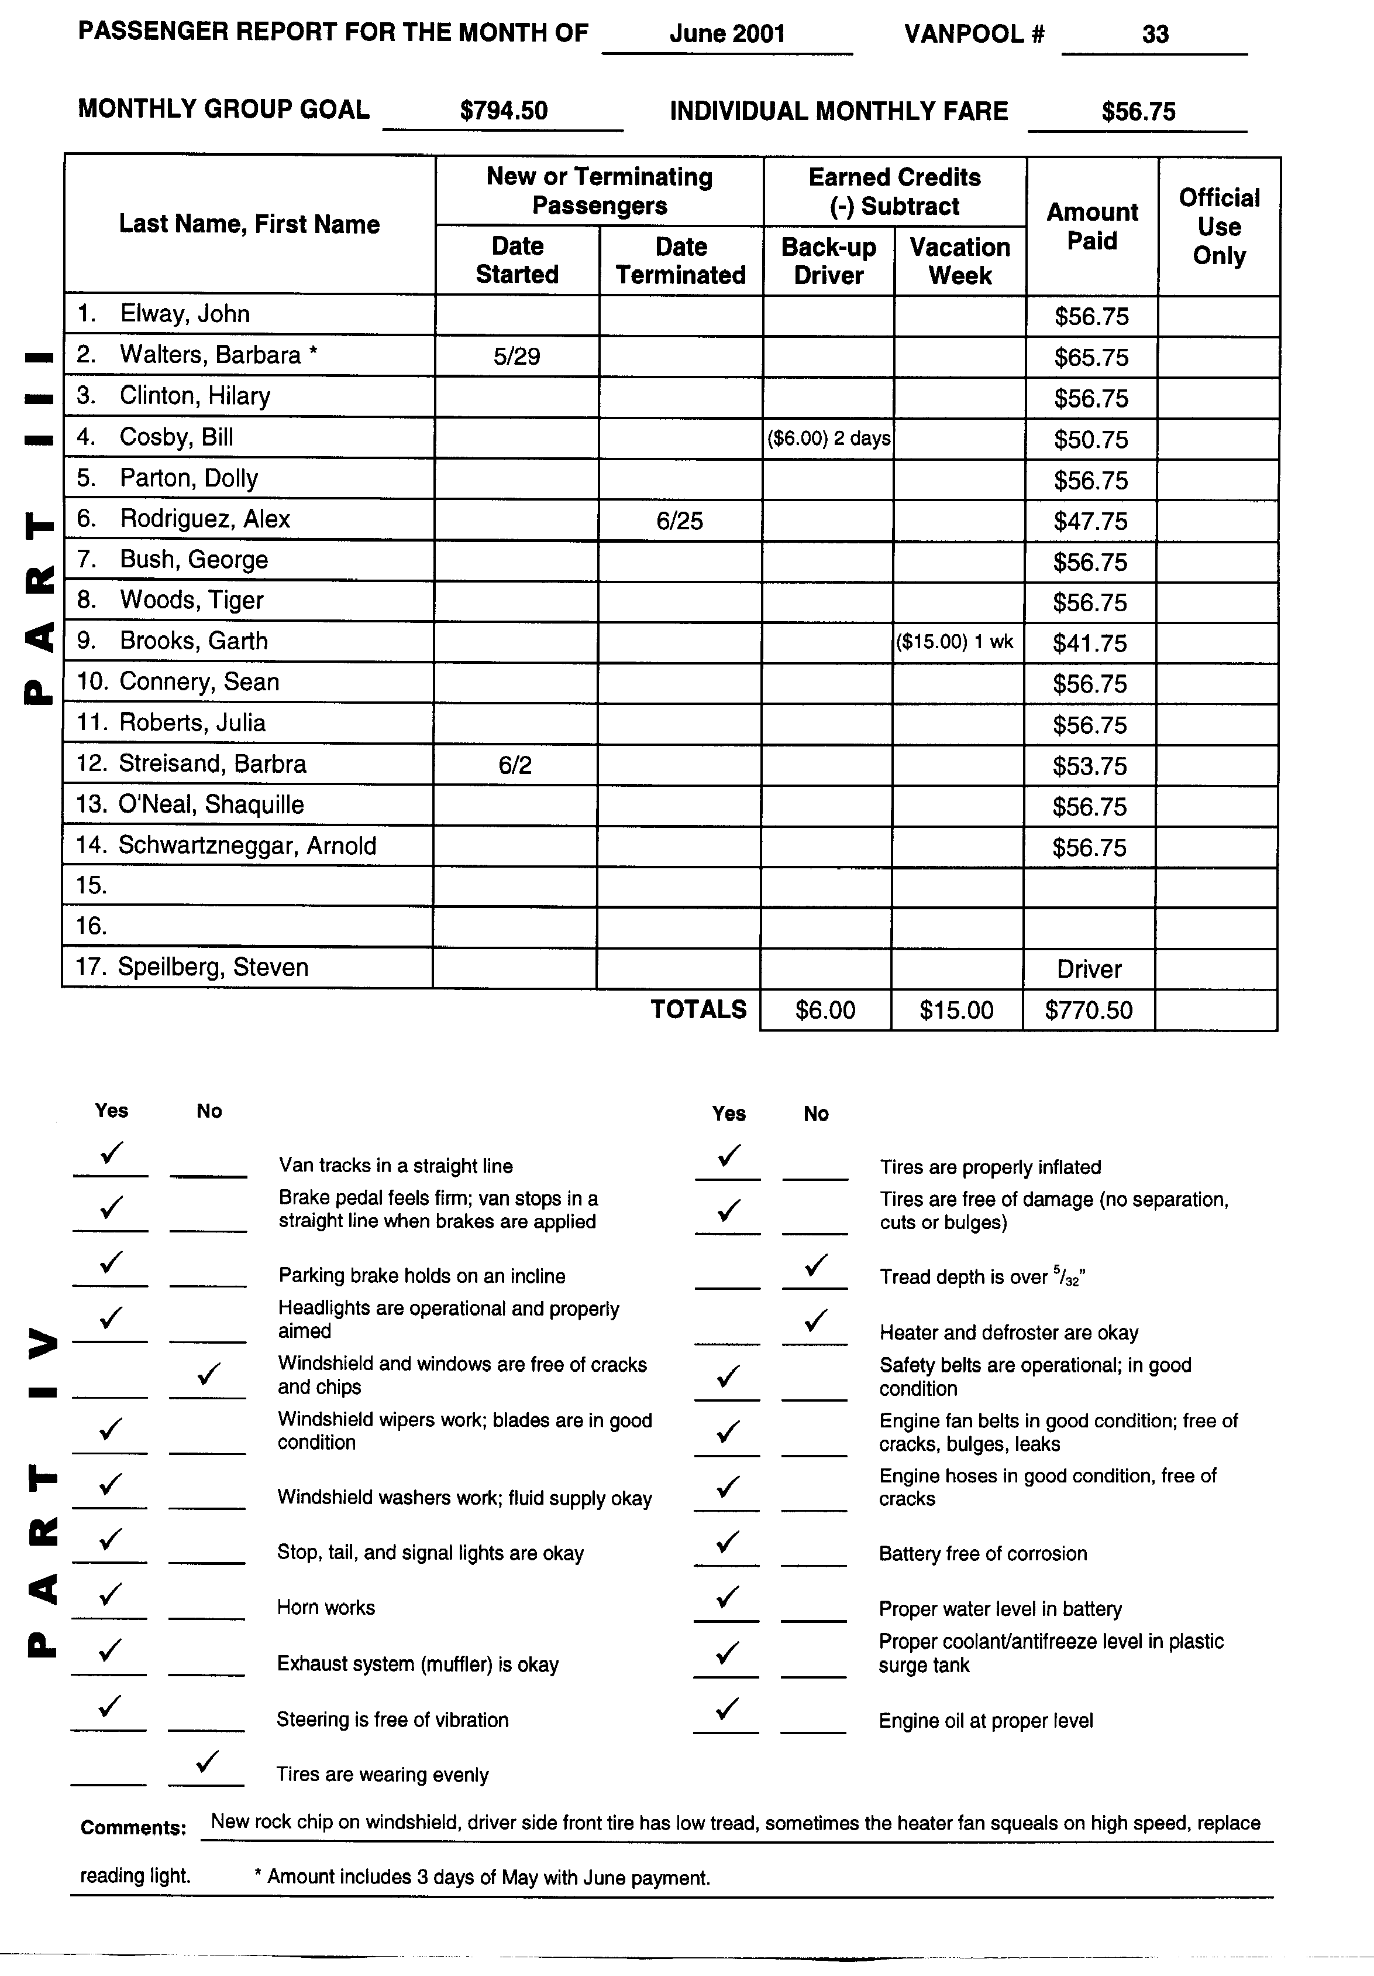

Miles Traveled
The mileage a rideshare travels is divided into two categories: commute and non-commute. The vehicle's monthly rates are determined by the commute miles only.
- Commute Miles – Commute miles are the miles traveled from home to work and back.
- Non-Commute Miles – Non-commute miles are the miles traveled for fueling, cleaning, or servicing the vehicle. They also include all the miles that are traveled to do other rideshare business needed to maintain the vehicle.

Report Submittal
The following report elements are due to Asotin County PTBA by the 10th of the month:
- Monthly fares collected from passengers for the current month. *
- New Rideshare Agreements.
- Previous month's fuel receipts.
*If you have one or two late-paying passengers, send the completed paperwork without their checks so we can still be accountable to the company. If checks are missing because of late-paying passengers, tell us with a brief notation by their names. We need to know the paid status of all passengers every month. Please list all passengers, even if they have not yet paid, so that we can collect from them.
Fares unpaid for 60 days, by any individual, will result in denial of service and passenger’s name will be sent to a collection agency.

SUBSIDY OR FULL FARE REIMBURSEMENT

Some groups are fortunate enough to have their employer paying fully for their shared ride or a partial subsidy. Asotin County PTBA is prepared to give receipts to groups or individuals if payment documentation is required. Asotin County PTBA staff will not be able to write receipts if the vehicle groups’ total fare has not been met.

ACCIDENT PROCEDURES

At the Accident Scene
1. Protect the scene. Turn on the hazard flashers and have a back-up driver put out the red triangles from the kit at the rear of the vehicle. Use extreme caution and safety when placing the triangles. (See discussion and directions on pages 42 and 43, figures 2,3,4.) Use your horn at short intervals if visibility is poor.
2. Determine if any injuries have been sustained. Exercise cautious judgment if you must move passengers to safety. Identify geographical location of accident so that help can be dispatched. Collect your thoughts, be calm, know what you want to say before you place any call.
- Secure medical assistance for any injured persons and traffic support by dialing emergency phone numbers 911.
- Immediately report to Asotin County PTBA that an accident has occurred. Call 1-509-758-3567 (this is the phone number in decals on the side of each vehicle.)
5. Do not move the vehicle or pick up vehicle parts that may be lying on the ground unless absolutely necessary to avoid another collision. Both actions could certainly destroy evidence.
- Exchange Information. Do not admit fault.
- Within 24 hours of the occurrence, the driver involved in the accident must prepare and submit an Event Report to Asotin County PTBA detailing what happened. This form is found in the Accident Packet in your notebook.
- All witnesses, including all of the vehicle passengers, must be asked to fill out a Witness Courtesy Card. These cards are found in the Accident Packet. Make sure that any injuries are listed on the individual's completed Courtesy Card.
- The driver must also fill out an Asotin County PTBA Rideshare Body Damage Report. This form is also found in the Accident Packet.
- All completed paperwork should be delivered to Asotin County PTBA immediately. Make sure you stock a new Accident Packet in your vehicle in case there is need again in the future.
- If any Law Officers are at the scene, they will fill out a State Report. We will need a copy. This is mandatory.
- If only minor property damage is involved or the accident is on private property, no police officer will respond. Please remember that even if both vehicles can be driven the rideshare staff wants to hear about the accident and discuss what to do next. Exchange names, addresses, insurance companies, driver's license numbers, and vehicle license plate numbers with the other driver.
- Rule: If the accident involves $500 or more in damage, or there is an injury or death, notification must be made to:
- Local city police if the accident occurred in city limits.
- The Sheriff's Department if the accident occurred in the county.
- The Washington or Idaho State Patrol if the accident occurred on a state highway or outside the city limits.
- A Rideshare driver involved in a serious accident shall not be allowed to operate a vehicle following such accident until cleared by Asotin County PTBA.

During and After the Accident
1. Drivers should refrain from discussing an accident, either at the scene of the accident or at a later time, except with the police or an Asotin County PTBA representative, insurance adjuster, or the Asotin County PTBA attorney. All other parties not listed above should be referred to the offices of Asotin County PTBA.
2. When collecting the Witness Courtesy Cards remain professional, but never coach a person on what to write. Remember that a witness could be the deciding factor to an accident. Their support in a case could be very crucial. Here are some tips:
- Advise that it is your duty to secure the names of all persons who are nearby.
- Do not pass up a person who says, "I did not see the accident." Adapt your personality to a friendly, persuasive style to get the information needed.
• Make sure you can read their writing when you pick up the card, then thank them for their help.
3. Your vehicle will be replaced with a spare, until we can have a complete safety check, get estimates of damages and order parts for repairs as necessary.

Form 5. Event Report. (2 Pages)

( ) Potential Claim ( ) Information Only ( ) Call to Discuss ( ) Possible Subrogation for Transit

WASHINGTON STATE TRANSIT INSURANCE POOL
EVENT REPORT

Asotin County PTBA (Incident or Accident)
Rev: 04/19/2001 EVENT INFORMATION
Event Date: Time: am / pm

Circle Event Indicator: Incident / Passenger / Vehicle Event / Customer Contact / Wheelchair / Pedestrian / Property Damage
Please Circle Dept: Fixed Route / Rideshare / ParaTransit / Dial A Lift / Maintenance / Administration / Worker-Driver / Contract

Circle One: Investigating Supervisor / Police Officer / Security Officer / Other Employee / None / Request Debriefing
Date Investigated: Investigator Name: Rpt. #:
TRANSIT DRIVER'S DESCRIPTION OF EVENT
Transit Driver Signature: Date Signed:
Action Taken:
What statement was made by the other party?
Part(s) of Other Party Vehicle or Property Damaged:
Describe Transit Vehicle Damage: |  |  |  |  | Most Injured Party: |  |  |  |  |  | Total Injured:
 |  |  |  |  | Other Injured Parties: |  |  |  |  |  | Total Fatalities:
EVENT DETAIL
Location Address, City & County:
Route No. Run No. |  |  |  |  |  |  | Company Vehicle #:
City: |  |  |  |  |  |  | County:
Circle ONE Primary Location:
Alley | Railroad Tracks |  | Bus Shelter/Zone |  |  |  |  | Member Vehicle |  | Const. Zone |  | Driveway
Hill | Freeway/Interstate |  | Walkway/Sidewalk |  |  |  |  | Intersection |  | Parking Lot |  | Steps
Bridge | Residential Street |  | Mall/Shopping Center |  |  |  |  | Transit Facility |  | Highway |  | Street
URBAN |  | SUBURBAN |  | RURAL |  | PRIVATE PROPERTY |  |  | MEMBER PROPERTY

Form 5. Event Report. (2 Pages)
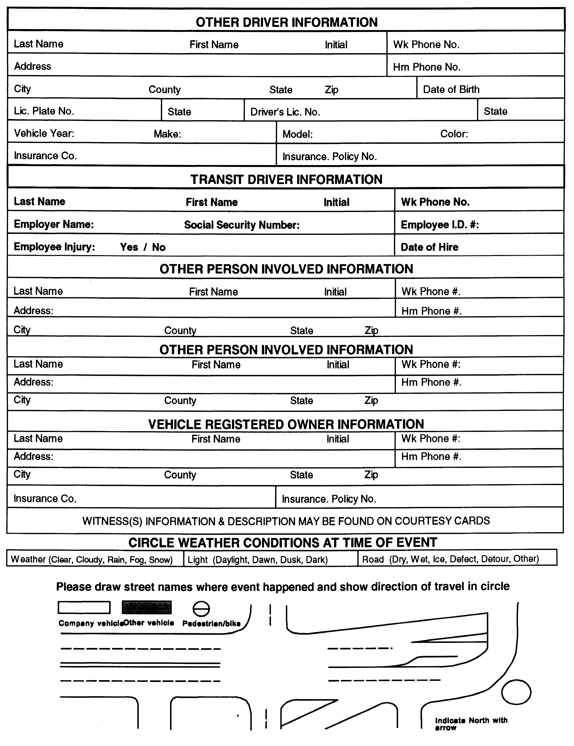

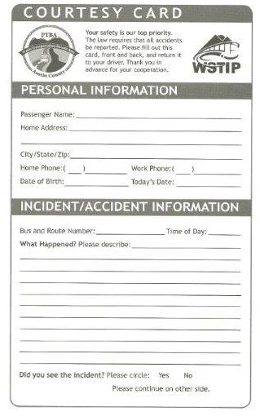
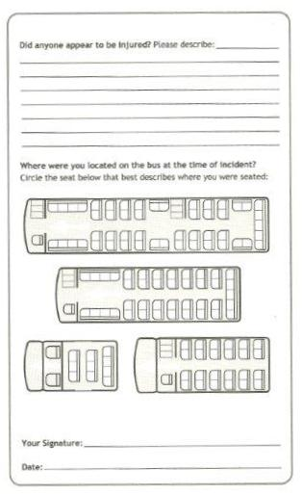

Form 6. Witness Courtesy Card.

After collecting the Witness Courtesy Cards, note any physical problems someone might be experiencing, such as lacerations, neck pain, bruises, etc.

MOre safety advice
Take all precautions necessary to protect the scene of the accident from further collisions. The State of Washington Department of Licensing Commercial Driver's Guide recommends the following actions:
- Be visible. When your vehicle is disabled at the side of the road be sure to turn on the 4-way emergency flashers. This is important at night. Do not trust the taillights to give warning. Drivers have crashed into the rear of a parked vehicle because they thought it was moving normally.
- If you must stop on a road or the shoulder of a road, you should also put out your reflective triangles within ten minutes. When putting out the triangles, hold them between yourself and the oncoming traffic for your own safety (so other drivers can see you). Place your devices at the following locations:
- On the traffic side of the vehicle, within ten feet of the front or rear corners, to mark the location of the vehicle. Figure 2
- 100 feet behind and ahead of the vehicle on the shoulder or in the lane you are stopped in. Figure 2
- Back beyond any hill, curve, or other obstruction that prevents other drivers from seeing the vehicle within 500 feet. Figure 3
- If you must stop on or by a one-way or divided highway, place warning devices 10 feet, 100 feet, and 200 feet toward the approaching traffic. Figure 4
C. Use your horn when needed. Your horn can let others know you're there; it can help to avoid another accident if visibility is poor.

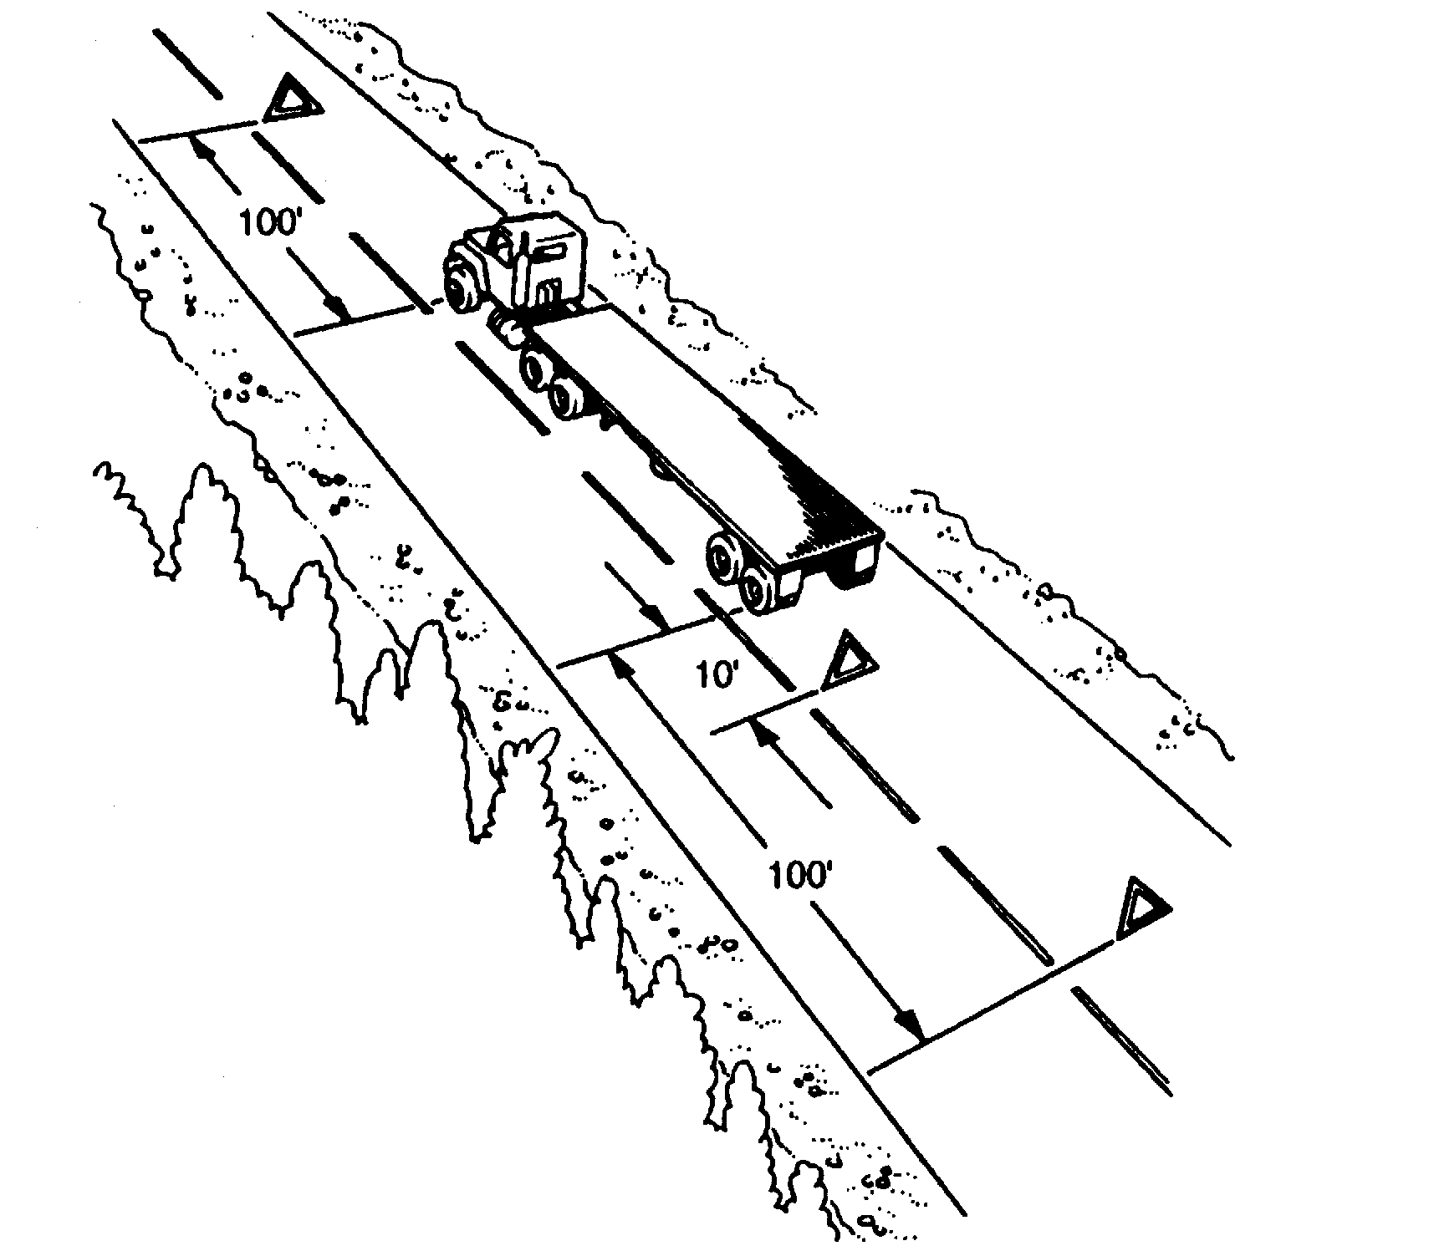
Figure 2. Warning Device Placement – Two-Lane or Undivided Highway.

Figure 3. Warning Device Placement – Obstructed View.
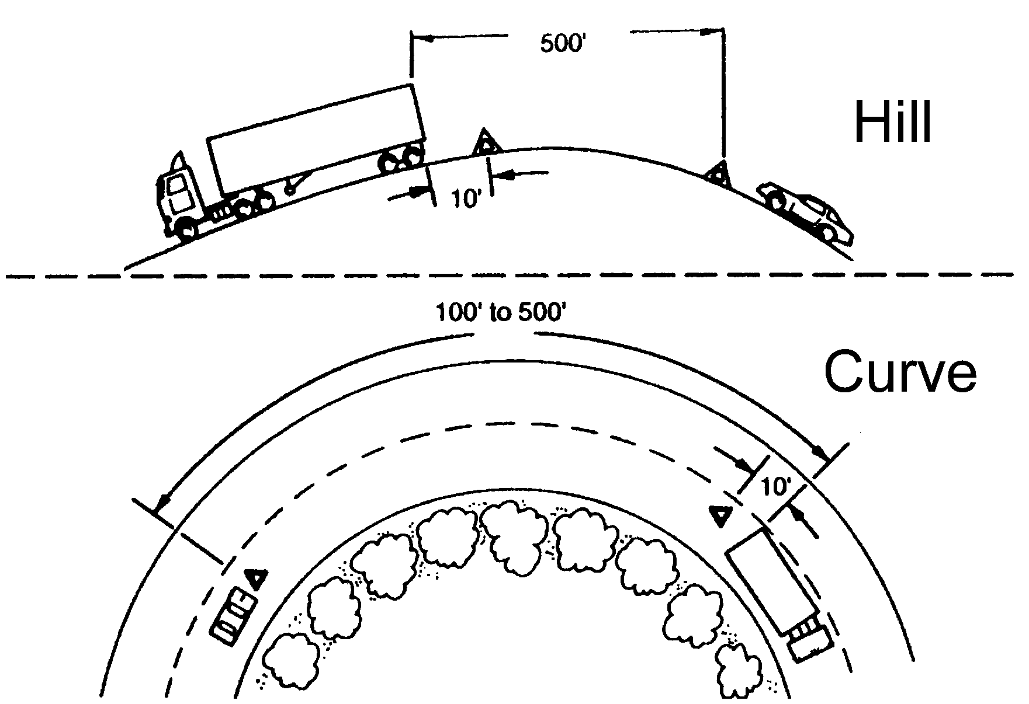

Figure 4. Warning Device Placement – One Way or Divided Highway.
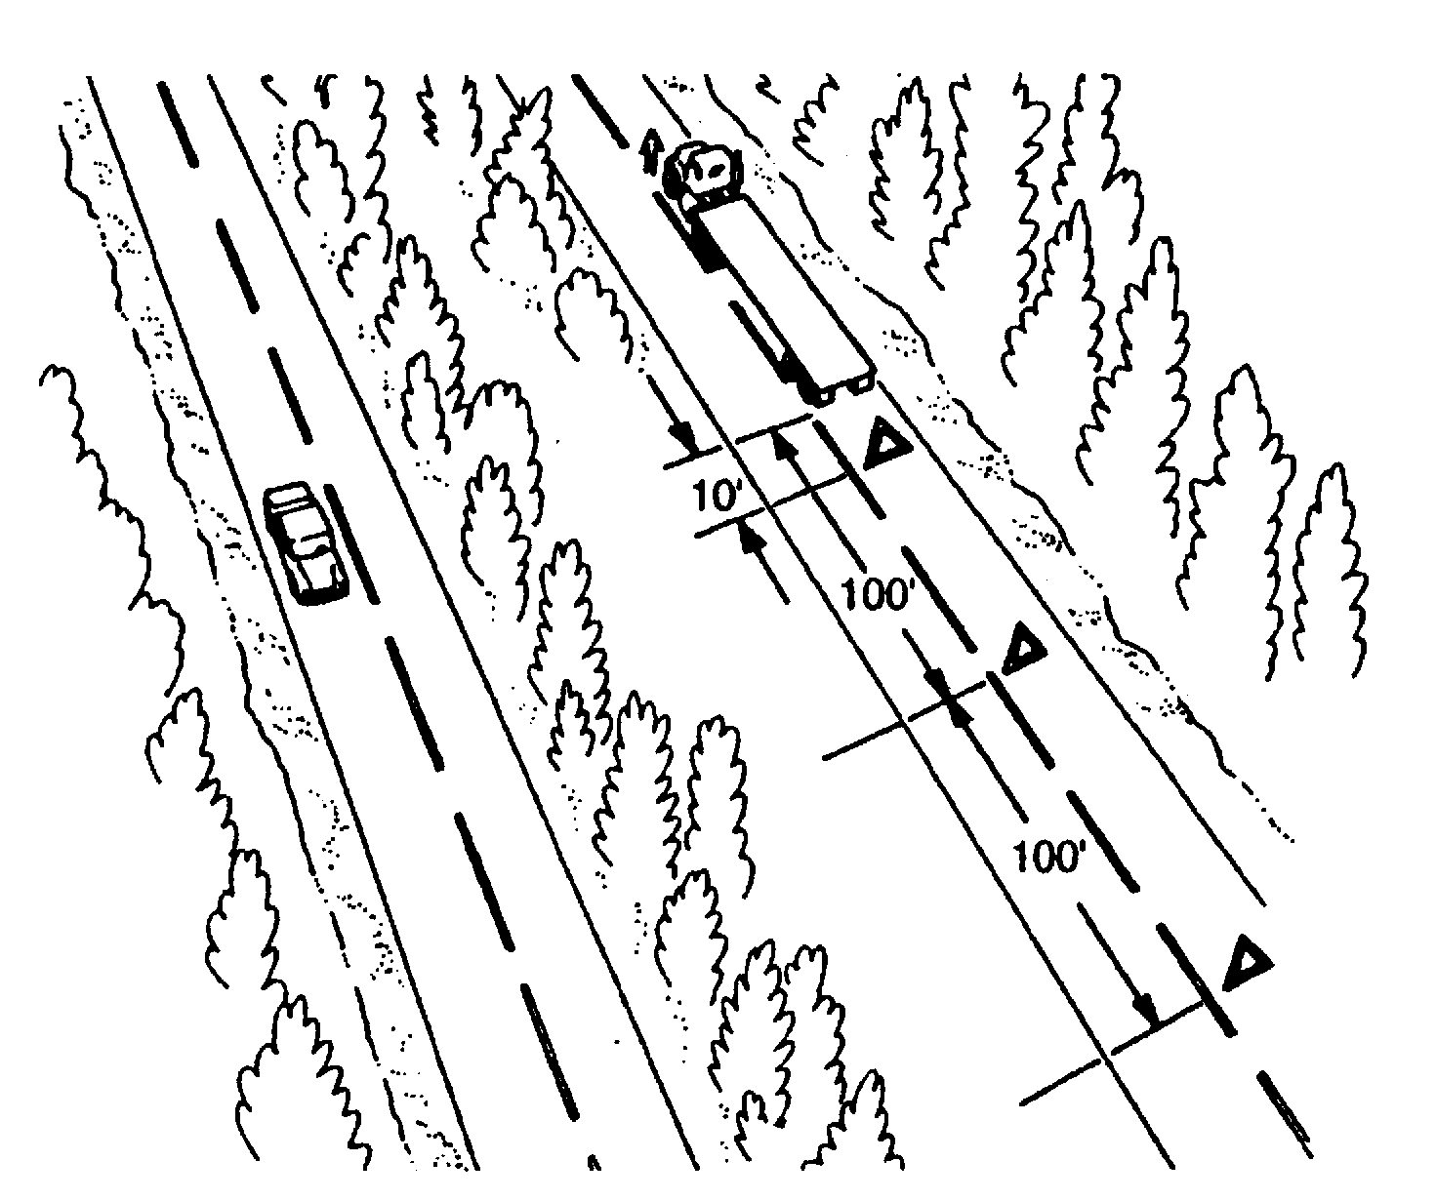

Form 7. Vehicle Body Damage Report. (2 Pages)

Asotin County PTBA
Vehicle Body Damage Report

Using the pictures below, circle and number the damaged areas. In the numbered spaces provided, list brief descriptions of damage, making sure that the number corresponds to the picture.

- _______________________________________________________________
- _______________________________________________________________
- _______________________________________________________________
- _______________________________________________________________
- _______________________________________________________________
Comments: ________________________________________________________
__________________________________________________________________
__________________________________________________________________

________________________ ___________________ ____________________
Driver Signature Date Witness Signature

VP Number __________________

Form 7. Vehicle Body Damage Report. (2 Pages)
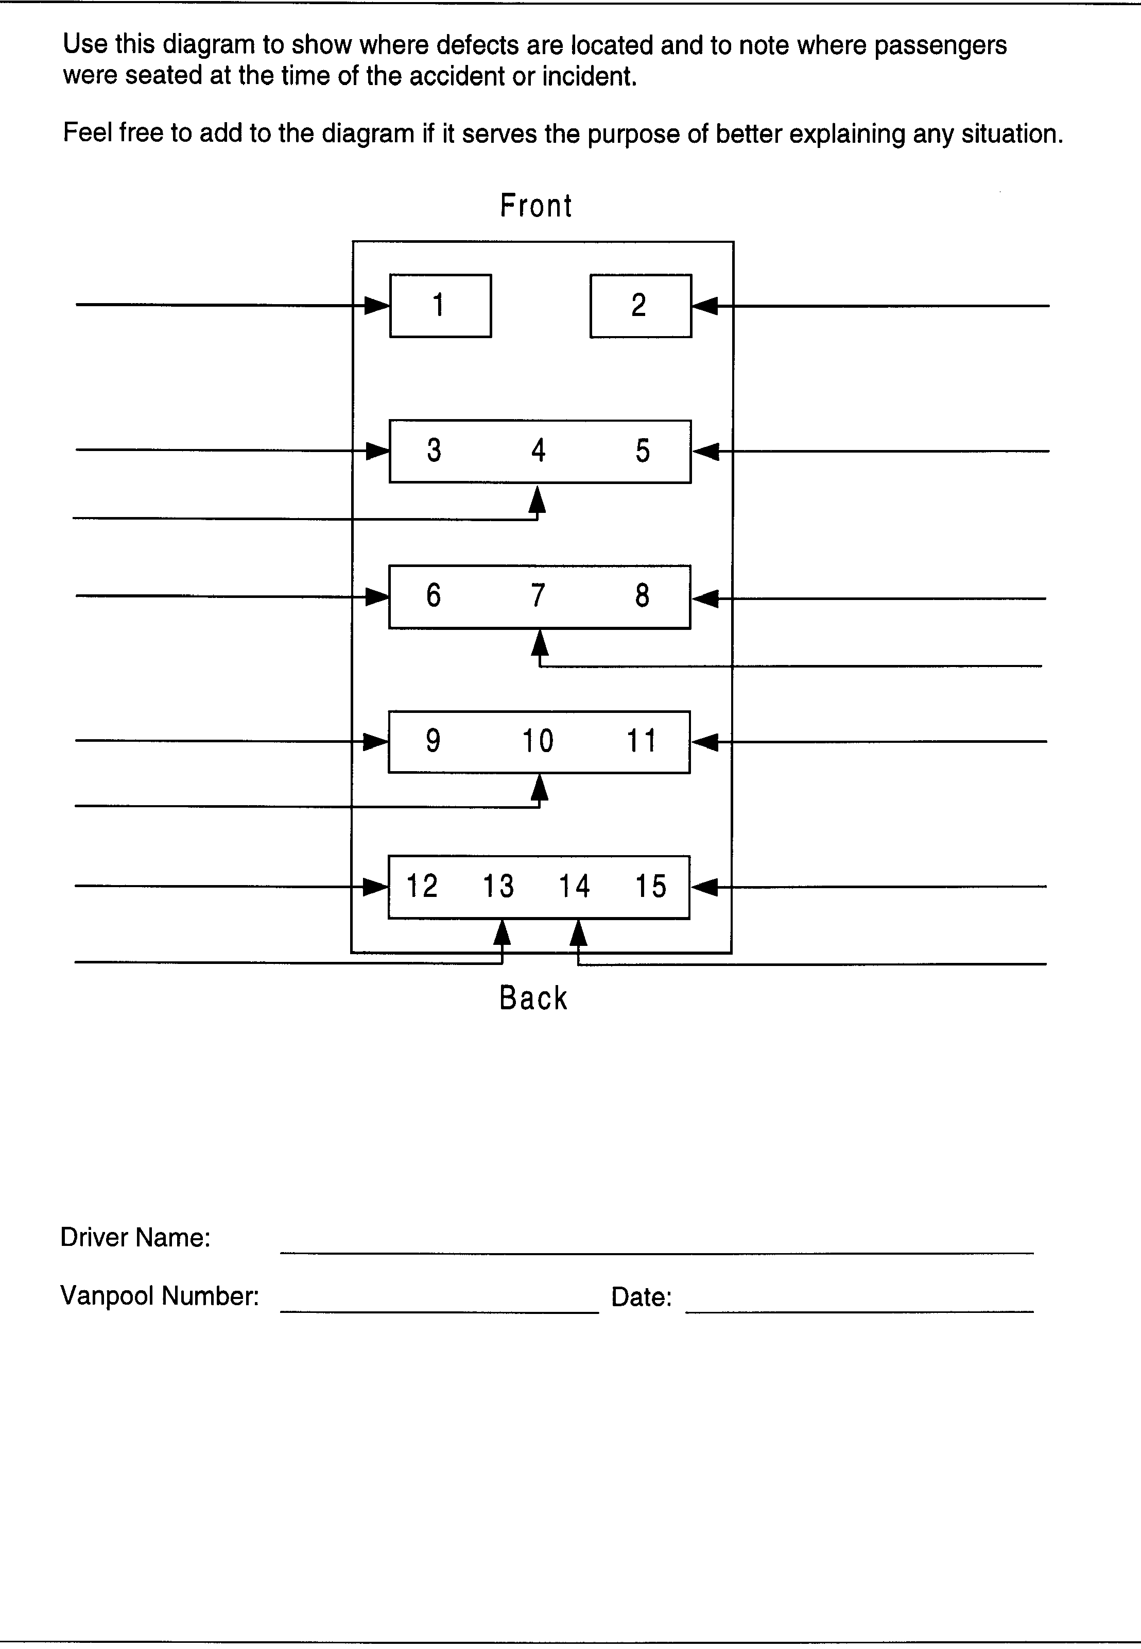

maintenance
It is the driver's responsibility to ensure that the vehicle is properly maintained. Maintenance scheduling and record keeping will be handled by the rideshare office staff. An email will be sent to the primary driver to facilitate timely coordination of oil changes and safety inspections. As a quality control measure, a "service due" sticker is also installed in the upper left-hand corner of the windshield to help you remind us when service should be performed. Minor defects and body damage should be listed in Part IV of the Rideshare Monthly Report.

Routine Maintenance and Repairs
Rideshare vehicles are on a preventive maintenance program, which requires that they be brought in for maintenance: Ford, every 4,500 miles or 90 days, whichever occurs first. Chevy, GMC and some of the lift vans will be every 5,000 miles. Drivers are asked to assist the rideshare service staff in the delivery and scheduling of their vehicles.
If a vehicle requires repair or develops mechanical problems between service dates, the driver should call the rideshare office staff immediately. Staff will then schedule service as needed. Most likely, you will be assigned a spare vehicle. Loaner vehicles are available through the Asotin County PTBA office. Know your vehicle so you can alert us to possible mechanical problems.
- Read the vehicle's owner manual.
- Learn the characteristics of your vehicle so you can feel, hear, see, or smell when something is wrong.
- Know where all emergency exits are, how to open any hidden latches, and the location of the first aid kit, fire extinguisher, spare tire, and jack.
- Know how to use the fire extinguisher and how to change a tire.

Preventive Maintenance
There are some simple techniques that will ensure safe, reliable performance of your vehicle. They are habits that, if performed daily, will keep you on top of possible maintenance problems that could arise.
- Check your vehicle's oil each time you fuel the vehicle.
- As you approach your vehicle or leave your vehicle, be aware of any fluid leaks. Check the ground under the engine for any drips that are fresh. Try to identify the color or placement. Call the rideshare office staff for advice if you spot any fluid leaks.
- Pre-trip your vehicle. Walk around your vehicle and check for body damage, low or flat tires, mirror adjustment, the proper operation of all lights, and any obstacles that may be in the driving path.
- Allow your glow plugs to cycle. In cold weather, you may need to cycle twice, which could avoid hard-start or dead battery problems.
- Watch your gauges. The dash has indicators to alert you to potential problems.
- Listen to your vehicle. Sound O.K.?
- Do not run your vehicle out of fuel. A good safety net is to refill at the one-quarter mark on a single tank, if you are traveling a long route. Switch tanks at one-quarter full if you have a front and rear tank system. PLAN AHEAD.
- Allow your power stroke diesel engine's turbo charger to cool down after a long trip by idling for one minute. The slower speed allows engine oil to circulate and lubricate moving parts before the turbo stops. This preserves the life of the turbo.

Tires
If you have a question about the condition of your tires, please note it in Part II of the Rideshare Monthly Report or call the rideshare office. Items to be concerned about are uneven tire wear, tread depth, cupping, vibrations, and air pressure. (Tire pressure ranges are listed on a plate mounted in the driver's doorjamb.)

Safety-Related Defects
Any safety-related defect dictates that the vehicle be removed from service immediately! The driver must communicate what they perceive to be safety-related. Any defect not considered "unsafe" will be attended to at the next 4,500/5,000-mile service interval.

Windshield Repairs
Please report star rock chips and short cracks to the Rideshare staff right away. Windshields are usually repairable if the damage is filled soon. Windshields must be replaced if cracks run through the driver’s line of vision.

winter maintenance

Diesel Fuel Anti-Gel – Diesel Vans Only
When the temperature reaches 10°F and you fuel at commercial stations, (Asotin County PTBA uses a pre-treated winter blend) it is recommended that you add diesel fuel anti-gel in your fuel tanks to prevent the diesel fuel from freezing into a "gel" substance.
Use a 1-pint bottle per fueling in a 35-gallon tank. This anti-gel is stocked in the locker on the fuel island at Asotin County PTBA.
CAUTION: Do not store this liquid in your vehicle. The caps of these bottles are not on very tight. If spilled, the chemical fumes are extremely noxious and very difficult to remove from the carpet.

Engine Block Heaters
All diesel engine vehicles in our fleet are equipped with 110-volt engine block heaters that plug in at the front or side of the vehicle. When temperatures reach freezing, please plug in the heaters so that your engine will start easily. Extension cords are provided for you. When you do not use the block heater, you are unnecessarily taxing the starting system and parts will wear out sooner, costing the program more money.

Air Conditioning
It is important to run the air conditioning for about 10 to 15 minutes on a weekly basis throughout the entire year. The reason for this is so the air conditioning system is lubricated (internal seals, o-rings, etc.) through the off-season to protect the component parts.

Winter Tires
Upon the driver or group's request, studded snow tires will be provided to rideshare users whose route is comprised of 80 percent or more travel in rural areas. These will be areas where we expect the roads will not be sanded or plowed with the regularity that primary roads are maintained. Typically, we do not promote the use of studded snow tires.
CAUTION: Studded snow tires can provide a false sense of security and extreme caution should be used if driving with them.

Washing Your Vehicle
The Rideshare Program has budgeted for your vehicle to be washed once per month. The places authorized to wash your vehicle change periodically. Check with your Rideshare service representative for the currently authorized washing facility. Two options are credit accounts where no cash is involved. At this time, we do business with:
Splash  2131 13th Ave.  Lewiston, ID  (behind Pizza Hut off 21st St.) | Aqua Touch Car Wash  2009 17th Avenue  Lewiston, ID

Ask for an exterior wash, interior vacuum, and windows cleaned. Carpet shampoo and details are extra and must be coordinated with Asotin County PTBA.
At the car wash, you must remove the bike rack from the hitch receiver.

transmissions

Automatic Transmission
Your automatic transmission is electronically controlled. The transmission operation is controlled by the powertrain control module (PCM). The PCM will automatically adjust transmission operation to make up for varying conditions (hot, cold, rpm, throttle position, etc.) for the best performance and fuel economy.
To help in troubleshooting, the PCM continually performs self-tests on the electronic control system and if any faults are detected, will store them in memory. The transmission control indicator light (TCIL) will flash repeatedly if a malfunction has been detected. In some cases, the PCM will "order" the transmission to revert to the "manual" automatic mode of operation, and the transmission will feel "hard" and sometimes "clunky" between shifting gears. You will also see the "overdrive indicator button" light up and flash. It is not harmful for the transmission to operate in this mode, for short periods of time, but the vehicle should be checked as soon as possible by Asotin County PTBA’s mechanics. (There may be times when the engine is shut down, the PCM will reset itself and clear the "memory codes." This is normal but may be an indication to have the transmission checked at the maintenance shop.)

Emergencies
You should know what to do when an emergency situation occurs.

Brakes Fail
If your brakes fail, pump the pedal several times to build up pressure. If that fails, coast in gear and use the emergency or parking brake. If you need to slow faster, shift to a lower forward gear. Unless a brake line has been cut, you will still have brakes, so use your pedal too. You will find the brakes harder to press, but still effective. Get the vehicle off the road and park it in the nearest safe location.

Accelerator Sticks
If your accelerator sticks, shift to neutral, pull over to the shoulder of the road, and stop. You may try to lift the pedal with the toe of your shoe, but never take your eyes off the road while the vehicle is in motion. Remember, if you turn off the engine, it will affect the power braking and will most likely lock up the steering wheel. Do not turn the engine off.

Air Conditioning Compressor Failure
All of our Ford vans manufactured since 1992 have several components that are operated by a single serpentine fan belt. We have noticed that on occasion, the air conditioner compressor will fail or "freeze up." This can happen in the Defrost mode also, because the a/c compressor is involved with the de-humidifier process.
When this happens, additional stress is put on the single serpentine fan belt, and the additional components are threatened as well. If the belt breaks, the water pump, power brakes, and power steering will no longer work. Typically, when the air conditioner compressor fails, there is a lot of noise, some smoking (belt rubbing against the frozen pulley), and you will be aware something is obviously wrong.

What To Do

If you suspect your compressor has failed, put your dash slider control in the "vent" position. This will disengage the air conditioning compressor so that it will "free-wheel" and allow the fan belt to continue running without restriction.
View of Slider Control
OFF | MAX | NORM | VENT | FLOOR | DEF | DEF
 | A/C | A/C |  |  | FLR

breakdowns
If your vehicle should fail you en route, we will rescue you. It is acceptable to leave the vehicle and ride with other Asotin County PTBA rideshares that may stop to assist you, provided that you follow these safety precautions:
- As much as possible, pull the vehicle off the road, out of traffic.
- Turn on the hazard flashers.
- Set up red warning triangles, if necessary, to alert other commuters.
- Leave the keys for the tow truck operator or mechanic.
- Report the exact location to your rideshare service representative.

Preventable Road Calls
Valuable time and money are lost when a mechanic is called for maintenance assistance, and a rideshare group could be put at risk, or at least inconvenienced, in heavy traffic areas. Drivers should be alert to the following preventable breakdowns:
- Interior or exterior lights left on resulting in a dead battery.
- Keys locked inside the vehicle and no spare keys available. We have hide-a-key boxes available, and back-up drivers should carry their own set. Watch those electric door locks!
- The van was not plugged in during cold weather and will not start. This is a particular risk over long weekends.
- Wrong type of fuel for your vehicle. You will not get far putting unleaded fuel in a diesel vehicle.
- Running out of fuel. No excuses – please be aware!

Emergency Purchases
Most emergency situations can be handled by calling the number on the side of your vehicle (1-509-758-3567). This is a twenty-four-hour-a-day answering service that rings into Asotin County PTBA during normal business hours and rings into the answering service during all off-hours.
If you find yourself in a rare emergency situation, you are authorized to purchase up to $50 in emergency parts or fuel, and up to $100 in emergency road service.
CAUTION: As a publicly owned agency, Asotin County PTBA cannot make any cash reimbursements without a signed, legible receipt. BE SURE TO GET A RECEIPT!
You may staple the receipt to your next month fares check (if you are paying for the ride) and then deducting that amount. This makes a record of the purchase and is a quick way to get reimbursed. But, if you earn a total free fare by driving, this method will not work for you. Then you will need to come to the Rideshare office for assistance.

FUELING
Rideshare drivers are to purchase fuel at a CFN location. Each vehicle is assigned a Coleman Oil Gas Card and each driver is given a pin number.
If the card is not available be sure to get a receipt and put the rideshare number, number of gallons, the price per gallon, and legible signature.
Without the above information, Asotin County PTBA will not authorize payment.
Remember: If you take responsibility of a credit card, you need to treat it with respect and care. If it is damaged or lost, please notify the Rideshare Staff at once. Asotin County PTBA is trusting that you will not leave the card out in plain sight. Also, never leave it in the sun or near electronics that can de-magnetize the card.
Primary drivers and back-up drivers should discuss and agree upon their vehicles fueling plan, where and how often.

PUBLIC TRANSIT RIDESHARE AGREEMENT
Asotin County PTBA

This Agreement establishes the rights and responsibilities of parties as participants in the Public Transit Rideshare Program established by Asotin County PTBA, hereafter referred to as PTBA.
The Public Transit Rideshare Program, as referred to below, means the Rideshare Program administered by PTBA. Rideshare Group Coordinator, hereafter referred to as Coordinator, means the person or institution that governs the activities of an individual rideshare group. Driver, as referred to herein, means all persons who are approved by PTBA to operate the rideshare vehicle as an independent contractor. Bookkeeper, as referred to herein, means the person who has responsibility for collecting and submitting monies pertinent to the operation of the rideshare. Rider, as referred to herein, means all persons who ride in the rideshare vehicle, including the coordinator, drivers, and bookkeeper. If applicable, the Coordinator, Driver, and Bookkeeper may be one responsible individual.

THE COORDINATOR (MUST ALSO BE APPROVED AS A DRIVER) AGREES DURING THE TERM OF THIS AGREEMENT, TO:
- Establish, in cooperation with PTBA, the rideshare route and schedule to places of employment, education, or other institutions.
- Attempt to maintain the rideshare at its maximum ridership and keep PTBA informed of ridership changes.
- Coordinate maintenance, cleaning, and servicing of the vehicle as prescribed by PTBA.
- Obtain prior approval from PTBA for any expenditure relating to the safe operation of the vehicle, in excess of $50.00. Accessories, including appearance items or additional equipment, will not be added or removed without prior approval of PTBA. Any loss of such equipment will be reported by the Coordinator immediately. The rideshare group will reimburse PTBA for the loss of such equipment.
- Enlist and train sufficient Drivers (minimum of two per vehicle) to ensure continued operation of the rideshare.
- Coordinate the development of rules for the day-to-day operation of the rideshare (e.g., waiting times, music, etc.).
- Be responsible for the condition of the vehicle (e.g., maintaining proper oil level, maintaining PTBA tire air pressure requirements, and be accountable for vandalism when the vehicle is not parked in accordance with PTBA guidelines.
- Complete PTBA-provided training before taking possession of vehicle and assuming rideshare responsibilities.
THE DRIVER AGREES, DURING THE TERM OF THIS AGREEMENT, TO:
- Maintain a valid driver’s license as required by the State of Washington.
- Notify PTBA when (s)he is no longer in accordance with the established Driver Selection Criteria.
- Coordinate with PTBA-approved drivers the daily operation of the vehicle to and from places of employment, education, or other institutions, picking up and discharging riders in accordance the mutually established route and schedule. (RCW 46.74.010)
- Keep appropriate records as required by PTBA.
- Prior to driving the vehicles, attend the mandatory rideshare driver workshop, or at a minimum, participate in a vehicle orientation and on-road driving evaluation followed by attending one of the next two scheduled mandatory driver workshops.
- Observe safe driving habits and all traffic regulations. Any citation resulting from the operation of the vehicle is the responsibility of the person driving the vehicle at the time of the issuance of the citation. All PTBA-approved Drivers will report any citation resulting from a moving traffic violation to PTBA within 48 hours, whether received while driving the vehicle or any other vehicle. PTBA reserves the right to conduct annual Motor Vehicle Record checks to determine if a Driver continues to meet the established Driver Selection Criteria.
- Be responsible for reporting any rideshare vehicle accident or incident involving bodily injury, property damage, or a third party immediately to PTBA. Such reporting is to include any injury to a rider of the vehicle even though no third party was involved (e.g., riders falling and injuring themselves while entering the vehicle). The Driver is responsible for completing a Washington State Motor Vehicle Accident Report and submitting it directly to PTBA for all accidents or incidents, regardless of severity. PTBA will forward copies to the relevant agencies as needed.
- Collect the fares from all Riders in advance. Submit fares and records as required by PTBA by the 10th of each month.

THE BOOKKEEPER AGREES, DURING THE TERM OF THIS AGREEMENT, TO:
- Collect the fares from all Riders in advance.
- Keep and submit records as required by PTBA by the 10th of each month.
- Complete PTBA-provided training prior to assuming Bookkeeper responsibilities.
THE RIDER AGREES, DURING THE TERM OF THIS AGREEMENT, TO:
1. Pay his/her fare as established by PTBA; this payment will be made in advance to the Driver or PTBA by the first of the month.
- Abide by all day-to-day operational rules (i.e., waiting time, music, etc.) as established by a majority of the rideshare members.
- Notify his/her Coordinator in advance of all anticipated non-use of the vehicle. Find his/her own alternate transportation when work or personal schedule does not allow for riding the rideshare.
- Provide his/her Coordinator with fifteen (15) calendar days advance notice of planned termination.
- Not drive without express written or documented emergency telephone authorization from PTBA. (To drive without authorization could cause you to be at great personal financial risk).
- Wear/use safety belts properly at all times while occupying the vehicle.
THE COORDINATOR, DRIVER, AND RIDERS MUTUALLY AGREE, DURING THE TERM OF THIS AGREEMENT, TO:
- Assist in maintaining the rideshare ridership at its maximum level.
- Be held responsible for the cleanliness of the interior of the rideshare vehicle.
- Be held responsible for the vehicle and pilferable equipment (e.g., chains, reflector kit, spare tire, etc.).
- Abide by all rules, which may, from time to time, be established by PTBA. Abide by arbitration provided by PTBA in disputes arising out of the day to day operational rideshare rules. Agree to wear seatbelts at all times.
- Release the Driver and PTBA from any liability, claims, and demands for:
- Loss, theft, or damage to their personal property.
- Loss of income or consequential damages resulting from delays, tardiness, absence of the vehicle on particular days, or termination of the program.

PTBA AGREES, DURING THE TERM OF THIS AGREEMENT, TO:
- Provide a rider vehicle for use by the group.
- Execute agreements with Coordinators, Drivers, Bookkeepers, and Riders as needed.
- Provide bodily injury and property damage liability coverage at statutory limits for all authorized users of the vehicle.
- Assist in developing and maintaining the rideshare ridership at its maximum level.
- Coordinate establishment of the rideshare daily route and schedule.
- Provide an outline of all policy and operational aspects of the rideshare program.
- Provide all necessary report forms, including instructions for their completion and a submission schedule.
- Establish a fare schedule for participation in the rideshare.
- Establish a schedule for routine service and maintenance of the vehicle at PTBA approved maintenance facilities.
- Provide loaner vehicles by reservation on a first-come, first-served basis, for occasions when the rideshare vehicle is out of service.
- Assist in providing alternate transportation when neither the regular nor the loaner vehicles are available. For driving car pools on such days, drivers shall be credited an agreed upon amount per person for each day on which they drive.
- Provide sample rules and regulations for the daily operation of the rideshare.
- Provide one-week vacation credit every six months of consecutive participation as a paying rider in a PTBA vehicle.
THE AGENCY, COORDINATOR, DRIVER, AND RIDERS MUTUALLY AGREE, DURING THE TERM OF THIS AGREEMENT, THAT THE FOLLOWING REGULATIONS APPLY TO OPERATION OF THE VEHICLE:
1. The vehicle shall at all times be operated in a manner complimentary to the public nature of this program. The vehicle shall be kept clean, driven in a safe manner at all times, and not operated while under the influence of alcohol and/or drugs. All members shall act in a courteous manner and the unique character of this vehicle’s use shall be explained if such is questioned.
- Operation of the vehicle is restricted to PTBA-approved drivers. Prior to the operation of the vehicle, the driver must be authorized (for insurance purposes) in one of three ways:
- Attend the mandatory rideshare driver workshop prior to driving the vehicle.
- Receive a vehicle orientation and on-road evaluation prior to driving the vehicle (approximately 30 minutes). Follow up with attendance at one of the next two scheduled mandatory driver workshops.
- In an emergency, request temporary emergency authorization over the telephone from PTBA rideshare staff. If authorized for one-day trip, this emergency authorization must be followed closely with attendance at one of the next two scheduled mandatory driver workshops.
- The vehicle is to be parked off-street at the residence of a rideshare group member or other PTBA approved areas during non-commute hours.
- The vehicle is not to be used for hire; to pull trailers, boats, etc.; to haul garbage or excessive loads; or for any purpose requiring the removal of seats.
- The vehicle is to be driven only on hard surfaced streets and highways and other normal access roads and driveways.
- No personal use of the vehicle is authorized. The vehicle will never be left unattended with the engine running.
- Fares unpaid for 60 days may result in denial of service and use of a collection agency.

Asotin County PTBA Public Transit Rideshare Agreement

This agreement shall be effective as of the date of its signing, and shall continue in force until one of the parties gives the other party written notice 15 days prior to the planned date of termination. A Coordinator, Driver, or Rider may terminate the Agreement for any reason. PTBA may terminate this Agreement if fares are below the break-even point for two consecutive months, operation of the rideshare becomes inconsistent with the evaluation criteria established by PTBA, and/or the program/route is terminated. PTBA may terminate an individual for involvement in an accident, incident or safety complaint; failure to pay the rider fare promptly; failure to abide by any of the program's operating policies; unauthorized personal use of the vehicle; failure to abide by any of the terms of this Agreement; or for other good cause. Termination notification shall be confirmed by telephone or by mail to the last provided address. The affected party shall cooperate fully in return of all rideshare records, materials, the vehicle itself, and all keys thereto as appropriate within 48 hours of termination.

This Agreement may be modified only by subsequent written agreement signed by each of the parties.

The parties shall cooperate to ensure that no person shall be denied the opportunity to participate in nor be subjected to discrimination in the conduct of the rideshare because of race, creed, color, sex, age, national origin, nor the presence of any sensory, mental, or physical handicap, nor in any way contrary to applicable local ordinances, state and federal laws and regulation, specifically including, but not limited to, Title VI of the Civil Rights Act of 1964; Title 46, Code of Federal Regulations, Part 21 – Nondiscrimination in Federally Assisted Programs of the Department of Transportation; and, Chapter 49.60 Revised Code of Washington – Law Against Discrimination. I have received, read, and understand this agreement.

_____________________________________
Name (Please Print) PTBA Staff (Print) Date

Address PTBA Staff Title

City Zip PTBA Staff Signature

Work Phone Home Phone Date

Guaranteed Ride Home Program
Limited Usage – Abuse not tolerated *

Asotin County PTBA’s Guaranteed Ride Home Program will bring you to town from your work site for these emergency reasons:

- You or an immediate family member is sick or injured.
- Family or home crisis.
- Emergency business appointments.
- Unscheduled overtime where your employer won’t provide you a later ride.
- When your normal rideshare arrangement fails on homebound trip.

You must schedule your guaranteed ride home, Monday through Friday, by calling
(509) 758-3567
* 1st ride free, 2nd $20.00, 3rd $40.00

Signature Date

Vehicle #

E-Mail (Home) Address_________________________

E-Mail (Work) Address_________________________

(Check all below that apply)

C COORDINATOR
D DRIVER
B BACK-UP DRIVER
RI RIDER

All of the above are also considered a rider.

Employed by:

